Blue – Fixed Issues

Green – Still Working

URL: http://www.sciencetribes.com

Login Details: sri_mail03@yahoo.co.in / siri

Date: July 30, 2007

Test Criteria: New User without colleagues

- No message after successful registration
URL: http://www.sciencetribes.com/index.php?reg=1
- No verification / welcome mail.
- activation_link_resend
- unnecessary fields in membermaster table
- No Skype Info field in profile
- Next Should be Next>> in http://www.sciencetribes.com/mem_personal.php
- Organization Charges, Web Conferencing details are static. And No need to show Organization details to Individual member. http://www.sciencetribes.com/stcharges.php
- Not working in Mozilla http://www.sciencetribes.com/home.php#top
- Overview Page: Add Blog Link should go to Add Folder as there are no Folders. And No message for Files & Documents Block
- Add an Event or Meeting: Meeting term we are not using anywhere except here
- Show Message box width is less compare to other in http://www.sciencetribes.com/glossary_terms.php?crypt=Zm9sZGVyaWQ9M TY%3D
- While adding a term to Public Glossary, resulting error http://www.sciencetribes.com/glossary_termcreation.php?crypt=Z2ZpZD0xNiZzdD0x
- No message for View Organizations, View Colleagues when there are no items http://www.sciencetribes.com/glossary.php?crypt=dmlldz00 http://www.sciencetribes.com/glossary.php?crypt=dmlldz0z
- No help Doc for Documents, Chat, Phone, Messages, Action List, registration- No Info For New Fields http://www.sciencetribes.com/help.php
- No result message for empty search in http://www.sciencetribes.com/projects_search.php
- Moderator Account not yet created
- Forum has 5 levels of permission. But it is displaying 3 levels only in http://www.sciencetribes.com/introduction.php
- When no services created, and tried to create project first. It is allowing creating, but rising error in second step.
- Without completing the project creation wizard it is showing these links in second step Edit | Assign Services | Invite | Members | Remove
- no_online_colleagues
- By default chat availability is disabled
- Adding a contact to address book resulting error. And echo statement in the same page. Source: Invite.php
- No Cancel button in invite.php
- Replace the {sitename} in message body. And Preview Not showing entire content. http://www.sciencetribes.com/invite.php
- When no services, no message in Assign services page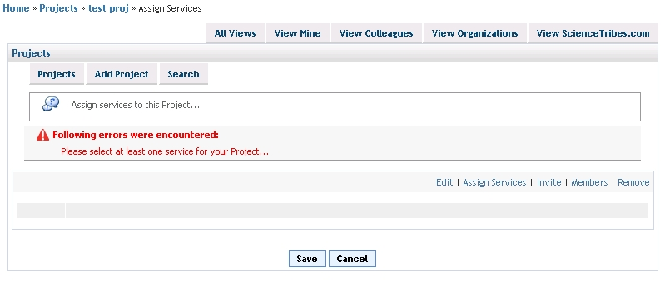
- Why Username in ST Invitees tab in http://www.sciencetribes.com/invitation.php
- Invite New Colleague link is resulting in the same popup And When No colleagues it should not allow to compose message. http://www.sciencetribes.com/compose.php
- No indentation in http://www.sciencetribes.com/msg_createfolder.php
- When no messages it should not show From, To Headings http://www.sciencetribes.com/msg_folders.php
- When Search Fails result display should be standardized http://www.sciencetribes.com/msg_search.php
- No Colleagues message is not displayed in http://www.sciencetribes.com/voip.php & http://www.sciencetribes.com/addconnection.php
- No Button in http://www.sciencetribes.com/landline_invite.php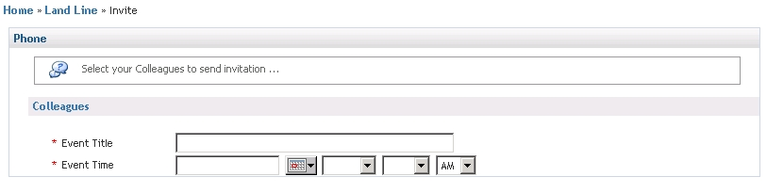
- No error message display in http://www.sciencetribes.com/forums_home.php?crypt=dmlldz00 when no items
- No Archives. Message should come from dictionary http://www.sciencetribes.com/service_archives.php?crypt=c2VydmljZT1GT1JVTVMmc29ydGtleT1OYW1l
- Add Folder From Add Forum: If I Click on Cancel Button, It should come back to add forum page instead it is returning to forums home page
- Permissions field is mandatory in some creation wizards, and not same in the others
- service_members.php is not aligned properly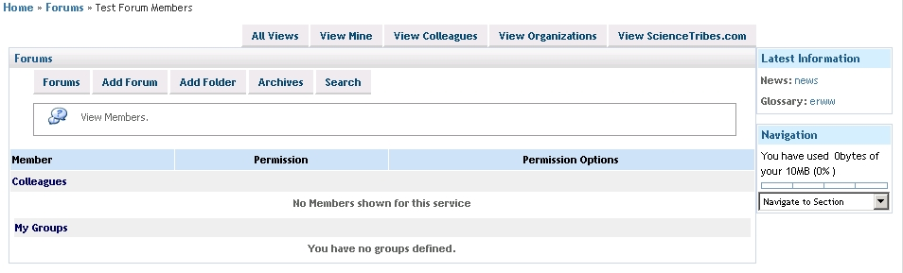
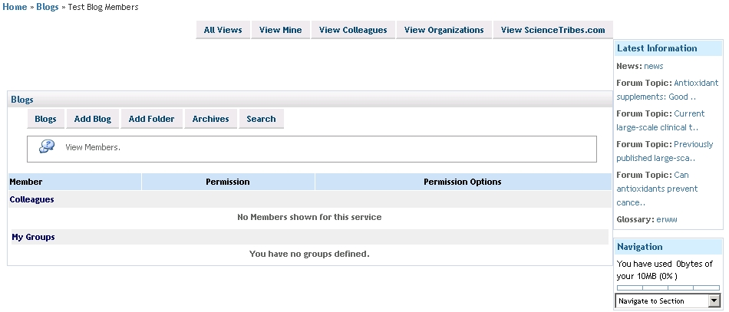
- Alignments:
  - postatopic.php
  - sub tabs in forum_reply.php
  - blogcategorysetup.php
  - blog_post.php
  - createEvent.php
  - eventDetails.php
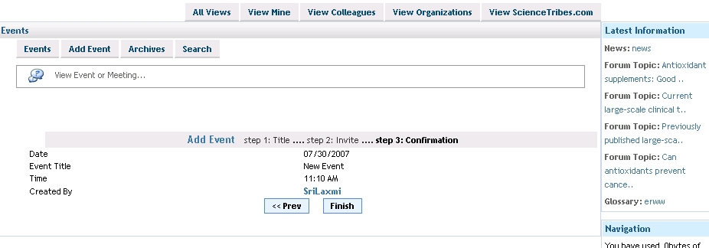
  - searchPoster.php
  - createPoster.php
  - postersetup2.php
  - show.php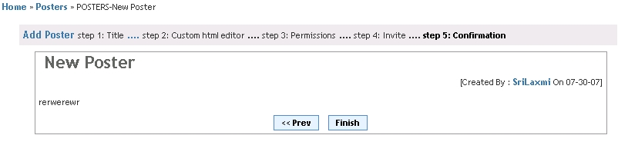
  - articlesearch.php – description
  - article_detail.php
  - Email This Article
  - article_details.php – title is not same as others
  - news.php

- No Cancel Button in postatopic.php
- In forum_reply.php after entering comment I clicked Cancel. Again When I Click on Comment link, it is showing previous content
- permission link in forum reply resulting to unauth page
- in the right menu Latest Info, it is resulting to unauth page http://www.sciencetribes.com/forum_reply.php?crypt=dG9waWNpZD00Nw%3D%3D
- For Comment & reply it is showing the same message saying Comment Posted Successfully
- Should not display Blog Archives when No Blogs in Archives
- When I view my profile showing permissions on that item http://www.sciencetribes.com/profile_forums.php?crypt=cHJvZmlsZWlkPTE1Mg%3D%3D
- http://www.sciencetribes.com/blog_post.php?crypt=YmxvZ2lkPTc5 Error is: Post Content should not be blank...
- http://www.sciencetribes.com/viewblogcomments.php Fatal error: Call to undefined function: getmemberrecentprojects() in /homepages/44/d174641939/htdocs/newbeta/site/includes/header.inc.php on line 33
- http://www.sciencetribes.com/createEvent.php Start Time Mins, Hours showing 2 times
- http://www.sciencetribes.com/eventHome.php?crypt=dmlldz0y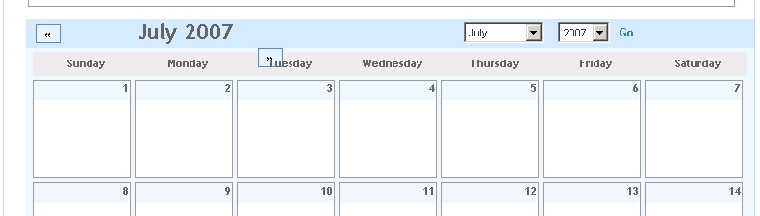
- http://www.sciencetribes.com/profile.php?crypt=bW9kZT1ldmVudCZwcm9maWxlaWQ9MTUy
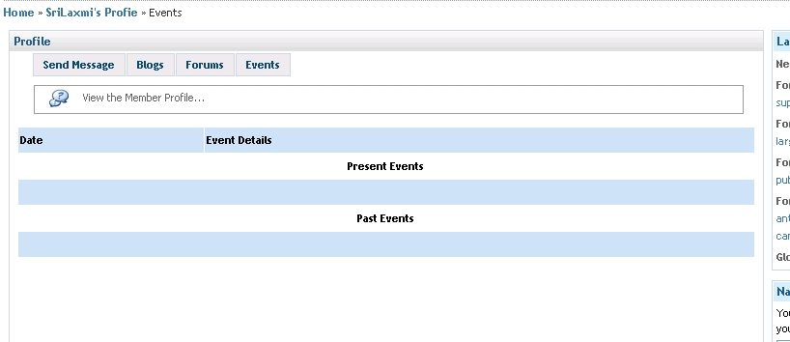
- empty search is not done in http://www.sciencetribes.com/searchEvent.php
- empty search is not done in http://www.sciencetribes.com/searchPoster.php
- While editing an inactive poster, it is showing it as active
- In poster edit, if we click cancel in last step it is not returned to posters home
- http://www.sciencetribes.com/search.php search for posters with empty string. And the results link is not defined correctly
- No message when no items in http://www.sciencetribes.com/folders.php?crypt=dmlldz00 , http://www.sciencetribes.com/folders.php?crypt=dmlldz0z & http://www.sciencetribes.com/viewst.php?crypt=c2VydmljZT1QT1NURVJT
- When Creating a Folder From Create Poster Page, It is moving through 2 steps but showing 4 steps
- When there are images in Imager Gallery show this in Small area, rather than the present one
- When Uploading a image, in create poster wizard, if no image selected it is showing error but with upload fields are not visible.
- When no items are displayed headers should not display http://www.sciencetribes.com/poster_req_wait.php?crypt=cG9zaWQ9NTc%3D
- No class for Archives link, Folder Permissions resulting unauth http://www.sciencetribes.com/show.php?crypt=Zm9sZGVyaWQ9MzEmcG9zaWQ9NTc%3D
- Comments are not displayed. http://www.sciencetribes.com/show.php?crypt=Zm9sZGVyaWQ9MzEmcG9zaWQ9NTc%3D
- No Comments in show.php should come from dictionary
- Posters home showing archived posters
- Not working properly http://www.sciencetribes.com/searchPoster.php
- No message display when no items displayed http://www.sciencetribes.com/articles.php?crypt=dmlldz0z & http://www.sciencetribes.com/articles.php?crypt=dmlldz00
- Display order not working properly http://www.sciencetribes.com/service_archives.php?crypt=c2VydmljZT1BUlRJQ0xFUyZzb3J0a2V5PU5hbWUmbmFtZV9vcmRlcj1kZXNj
- Use nl2br where ever we display the content. Mainly in home pages and in display service pages and in print pages
- If we send an article as Email using Email This Article option, content is not aligned properly and no where it is showing site name.
- http://www.sciencetribes.com/article_details.php?crypt=YXJ0aWNsZWlkPTEx design is not same as in other services.
- design issue in http://www.sciencetribes.com/mem_account.php?crypt=dmlldz1wcA%3D%3D# 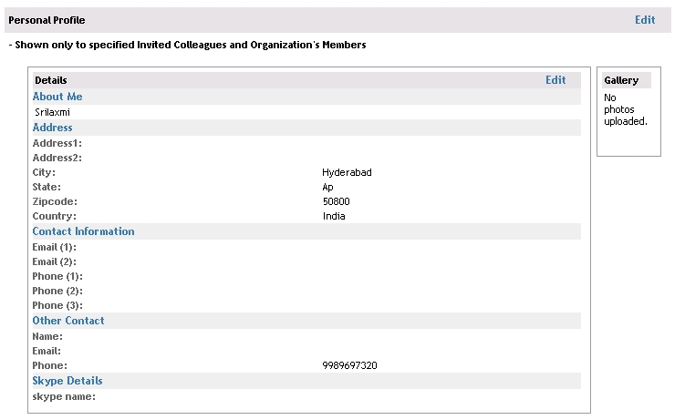
- No message display when no items display http://www.sciencetribes.com/news.php?crypt=dmlldz0z & http://www.sciencetribes.com/news.php?crypt=dmlldz00

August 2, 2007

- org_invite design
- org_profile
- No Sample Colleague when registered as a new user
- Organization registration
- org_sentinvitations.php
- No Cancel Button in org_invite.php
- http://webserver:8080/permissions.php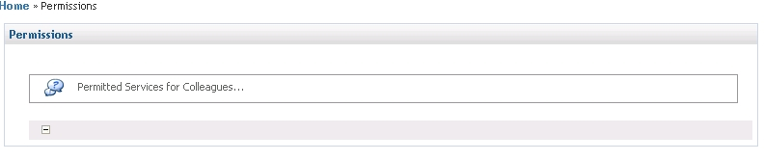
- org_invitation.php
- organization invitations accept not working
- sub tabs in address.php should be members page tabs
- design issue http://webserver:8080/organization.php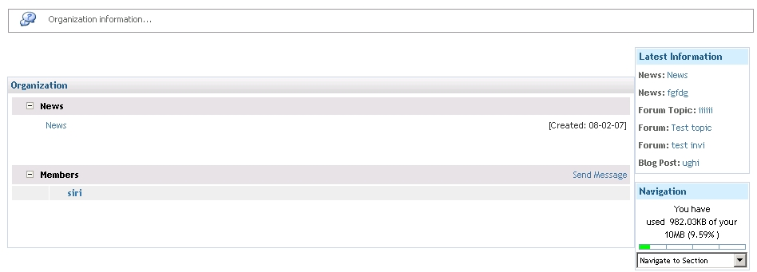
- display created by in news_details.php
- Mention mandatory fields in Profile while sending a message

Broken Links
In Footer:
- Home
- Products
- FAQ
- Disclosure
- Contact Us
- Promote
- Advertise
- Opportunities

Premium Members
Permission setting
Direct access to service_permissions.php, service_invite.php, permissions.php (change Permission link),

