Central desktop Web meeting Notes

Central Desktop Scheduled a meeting:

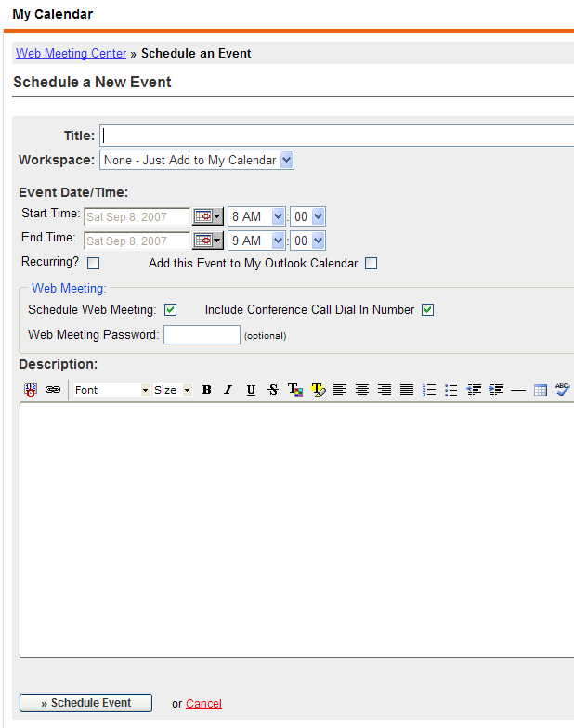

Result:

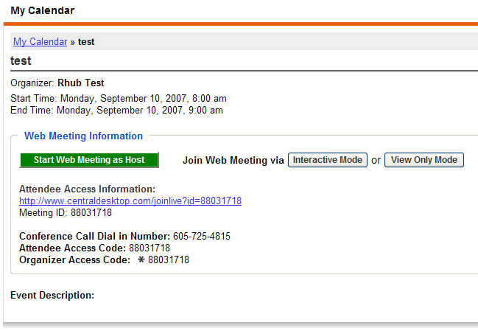

Key source code:

<!-- Begin Main Body Content -->
<div style="background-color: #eee; padding: 4px;"><a href="index?mycalendar">My Calendar</a> &raquo; <b>test</b></div><div class="standard_header"><span class="standard_header_right_side"><span class="padding_left_20"></span><a class="cd_icon_std cd_icon_left cd_icon_calendar_edit" href="index?mycalendar&sec=editevent&eveid=294670&event_type=single">Edit Event</a><span class="padding_left_20"></span><span class="ahref cd_icon_std cd_icon_left cd_icon_calendar_delete" onclick="common_calendar.delete_event(294670,'single');">Delete Event</span></span>test</div><div style="padding: 0 0 5px 0;"><span class="standard_header_right_side"><span class="ahref cd_icon_std cd_icon_left cd_icon_vevent" onclick="calendar_create_vcs(294670);" title="Add this Event to your Microsoft Outlook Calendar">Add this Event to My Outlook Calendar</span></span>Organizer: <b>Rhub Test</b></div><div style="padding: 0 0 20px 0;">Start Time: Monday, September 10, 2007, 8:00 am<br />End Time: Monday, September 10, 2007, 9:00 am<br /><br /><fieldset><legend><span style="font-weight: bold; padding: 0 5px 0 5px;">Web Meeting Information </span></legend><div style="padding: 7px;"><div style="padding: 7px 0 20px 0; font-size: 14px;"><input class="button" type="button" onclick="cdlive_host('1143170136-853109-1250182686','88031718', '','t','605-725-4815');" value="Start Web Meeting as Host" style="width: 190px; background-color: green; color: #fff; " />&nbsp;&nbsp;&nbsp;&nbsp;&nbsp;&nbsp;&nbsp;&nbsp;<span style="font-size: 13px; font-weight: bold; ">Join Web Meeting via</span> <input class="button" type="button" onclick="cdlive_join('88031718', '', 'Rhub Test','support@rhubcom.com','www','');" value="Interactive Mode" style="width: 110px;" title="Requires Client Download" /> or <input class="button" type="button" onclick="cdlive_join('88031718', '', 'Rhub Test','support@rhubcom.com','www','view_only');" value="View Only Mode" style="width: 110px;" title="No Download Required" /></div><span style="float:right;"><strong>Invite Attendees</strong>&nbsp;&nbsp;<span class="ahref redbold cd_icon_std cd_icon_left cd_icon_vevent" onclick="calendar_create_vcs(294670);">via Outlook</span> or <span class="ahref redbold cd_icon_std cd_icon_left cd_icon_email"" onclick="common_calendar.send_email_invite('Monday, September 10, 2007, 8:00 am','88031718','','t','605-725-4815','');">Email</span></span><span style="font-weight: bold; color: #333;">Attendee Access Information:</span><br /><a href="http://www.centraldesktop.com/joinlive?id=88031718">http://www.centraldesktop.com/joinlive?id=88031718</a><br />Meeting ID: 88031718<br /><br /><strong>Conference Call Dial in Number:</strong> 605-725-4815<br /><strong>Attendee Access Code:</strong> 88031718<br /><strong>Organizer Access Code:</strong> <span class="cd_icon_std cd_icon_left cd_icon_asterix">88031718</span></fieldset></div><div class="wiki_nonblock_content" style="font-size: 13px; padding: 0 0 20px 0;"><strong>Event Description:</strong><br /></div>
<!-- End Main Body Content -->

Clicking on Start Web meeting As Host:

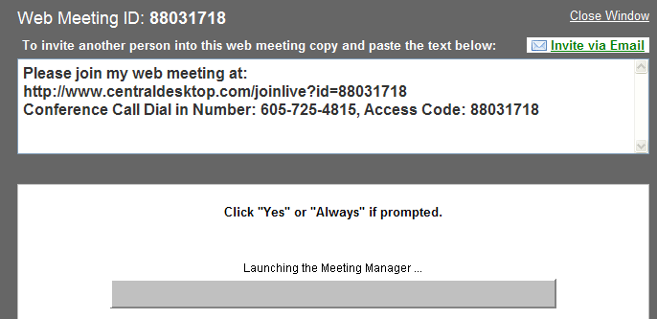

Key Access Code:

function start_screen_share() {
var participant_list = document.invite_members.participant_list.value;

if (participant_list == '') {
alert('You must enter at least one email address to start your Screen Sharing with.');
return false;
} else {

var invite_array = participant_list.split('\n');
if (invite_array.length > allowed_invites) {
alert('You are trying to invite '+invite_array.length+' people. You only have '+allowed_invites+' concurrent license(s).');
return false;
} else {
disablesubmit('submit_share','Starting... Please Wait...');
return true;
}
}
}

function invite_via_email(meeting_id, meeting_password, audio, conferencing_phone) {

var emailmsg = 'Please Join My Web Meeting at:\n'+
'http://www.centraldesktop.com/joinlive?id='+meeting_id;
if (meeting_password != '') emailmsg = emailmsg + '&pwd='+meeting_password;
emailmsg = emailmsg + '\n\n';

if (audio == 't') {
emailmsg += 'Conference Call Dial in Number: '+conferencing_phone+'\n'+
' Access Code: '+meeting_id+'\n\n';
}

location.href='mailto:?subject='+escape('Please Join My Web Meeting')+'&BODY='+escape(emailmsg);
}

</script>
…..
<a href="javascript:invite_via_email('88031718','','t','605-725-4815');" style="color: green; " class="redbold ahref cd_icon_std cd_icon_left cd_icon_email">Invite via Email</a></span>
<span style="padding: 0 5px 0 5px; color: #fff;">To invite another person into this web meeting copy and paste the text below:</span>
</div>
<textarea style="width: 100%; height: 100px; font-size: 16px; font-weight: bold; padding: 5px;">Please join my web meeting at:
http://www.centraldesktop.com/joinlive?id=88031718
Conference Call Dial in Number: 605-725-4815, Access Code: 88031718
</textarea>
</div>

<div style="border: 1px solid #c0c0c0; width: 100%; padding: 20px; margin: 30px 0 0 0; background: #fff;" align="center">
<strong>Click "Yes" or "Always" if prompted.</strong><br /><br />

<applet name="TurboMeeting" code="com.applet.installer.MainApplet.class" archive="/downloader.jar" width=500 height=100>
<PARAM Name="ManualDownloadURL" VALUE="http://www.centraldesktop.com/joinlive_meeting?g=&forcedownload=pc">
<PARAM Name="AutoDownloadURL" VALUE="http://live.centraldesktop.com/as/wapi/auto_download">
<PARAM Name="AccountServerIP" VALUE="live.centraldesktop.com">
<PARAM Name="AccountServerPort" VALUE="80">
<PARAM Name="Version" VALUE="3.0.23">
<PARAM Name="MeetingID" VALUE="88031718">
<PARAM Name="MeetingPassword" VALUE="">
<PARAM Name="ErrorURL" VALUE="http://www.gomeetnow.com/aspx/web_conference/common/GWErrorServer.aspx">
<PARAM Name="Publisher" VALUE="RHUB Communications, Inc.">
<PARAM Name="AboutURL" VALUE="http://www.rhubcom.com">
<PARAM Name="Role" VALUE="Host">
<PARAM Name="AttendeeName" VALUE="Rhub Test">
<PARAM Name="Email" VALUE="rhubtest">
<PARAM Name="UserPassword" VALUE="5f4dcc3b5aa765d61d8327deb882cf99">
</applet>
Clicking on Interactive Mode:

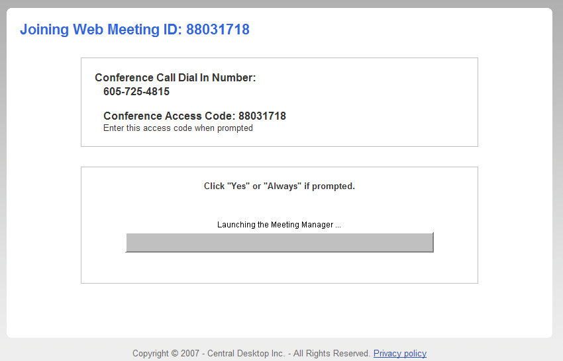

Source Code:

<h1 style="font-size: 22px;">Joining Web Meeting ID: 88031718</h1>

<div align="center"><div style="border: 1px solid #c0c0c0; width: 600px; padding: 20px; margin: 30px 0 0 0; text-align: left;"><div class="box_hdr">Conference Call Dial In Number:</div><div class="indent"><strong>605-725-4815</strong><br /><br /><strong>Conference Access Code: 88031718</strong><br /><small>Enter this access code when prompted</small></div></div></div>
<div align="center">
<div style="border: 1px solid #c0c0c0; width: 600px; padding: 20px; margin: 30px 0 0 0;">
<strong>Click "Yes" or "Always" if prompted.</strong><br /><br />

<applet name="TurboMeeting" code="com.applet.installer.MainApplet.class" archive="/downloader.jar" width=500 height=100>
<PARAM Name="ManualDownloadURL" VALUE="http://www.centraldesktop.com/joinlive_meeting?g=1746508wb9p4wpyvnv96rjlsab0ggmbasddv&forcedownload=pc">
<PARAM Name="AutoDownloadURL" VALUE="http://live.centraldesktop.com/as/wapi/auto_download">
<PARAM Name="AccountServerIP" VALUE="live.centraldesktop.com">
<PARAM Name="AccountServerPort" VALUE="80">
<PARAM Name="Version" VALUE="3.0.23">
<PARAM Name="MeetingID" VALUE="88031718">
<PARAM Name="MeetingPassword" VALUE="">
<PARAM Name="ErrorURL" VALUE="http://www.gomeetnow.com/aspx/web_conference/common/GWErrorServer.aspx">
<PARAM Name="Publisher" VALUE="RHUB Communications, Inc.">
<PARAM Name="AboutURL" VALUE="http://www.rhubcom.com">
<PARAM Name="Role" VALUE="Attendee">
<PARAM Name="AttendeeName" VALUE="">
<PARAM Name="Email" VALUE="support@rhubcom.com">
</applet>

</div>

Clicking on View only mode:

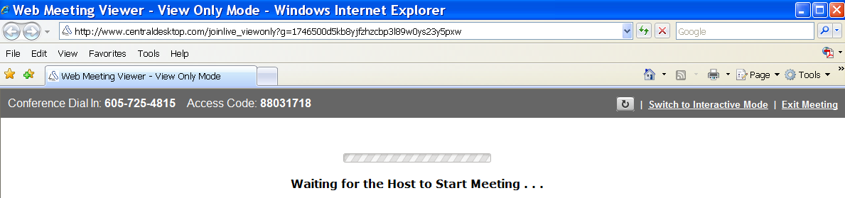

Source code:

<SCRIPT language="JavaScript">var gd=null;var md=305;var gdd=0;var U;var gRI={};var W;var gDid=0;var i=20000;var c=0;var d=0;function f(X,T){var a,V,x;if(!T)T=document;if((a=X.indexOf("?"))>0&&parent.frames.length){T=parent.frames[X.substring(a+1)].document;X=X.substring(0,a);}if(!(x=T[X])&&T.all)x=T.all[X];for(V=0;!x&&V<T.forms.length;V++)x=T.forms[V][X];for(V=0;!x&&T.layers&&V<T.layers.length;V++)x=f(X,T.layers[V].document);return x;}function RU(e,k){U=g();if(U==null){alert("You need to upgrade your browser or use a different browser");return;}gDid=e;c=1;d++;W="/deltareq";W=W+"?"+"mid=88031718&uid=136"+"&did="+e+"&count="+d;if(k==1){W=W+"&timeout=Y";}else{W=W+"&timeout=N";};U.onreadystatechange=j;U.open("GET",W,true);U.send(null);} function RUW(w){RU(w,1);} function j(){if(U.readyState==4||U.readyState=="complete"){if(U.status==200){eval(U.responseText);}}}function g(){var b=null;if(window.XMLHttpRequest){b=new XMLHttpRequest();}else if(window.ActiveXObject){b=new ActiveXObject("Microsoft.XMLHTTP");}return b;}function IL(Y){if(gRI[Y]!=null){c=1;var Z=gRI[Y];Z=Z-1;gRI[Y]=Z;if(Z==0){gRI[Y]=null;RU(Y,0);}}}function Start(){if(c==0){RU(gDid,1);}c=0;setTimeout("Start()",i);}</SCRIPT>
<body onLoad="Start()">
<div id="DLT">
<br><br><br><p align=center><font size=3><img border="0" src="/image/spinner.gif" width="220" height="19"><br><br><b>Joining Meeting . . .</b></font>
</div>

Click on Attendee Access Information link:

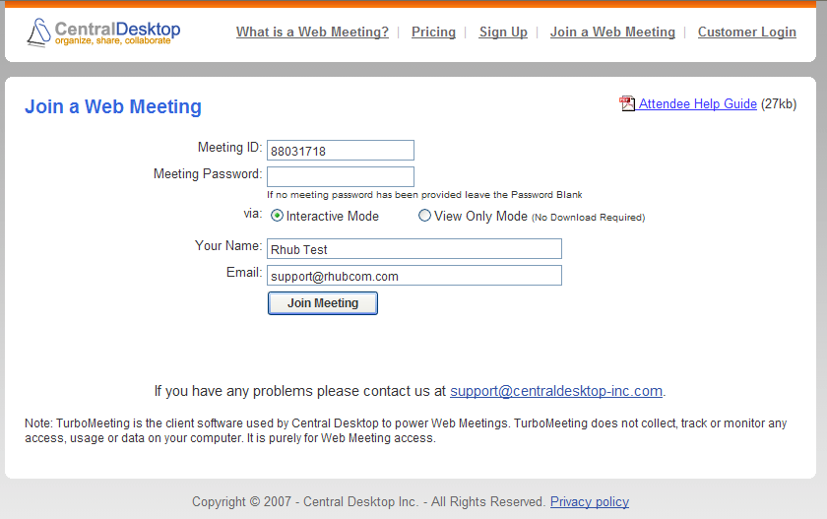

Key Source Code:
<script type="text/javascript" src="/js/prototype.v09032007.js"></script>
<script type="text/javascript" src="/js/xml.v09032007.js"></script>
<script type="text/javascript" src="/js/joinlive.v09032007.js"></script>

<div style="font-size: 15px;">
<div id="join_meeting_form" style="display:block;">
<span style="float:right;"><small><span onclick="window.location='/i/live/CDLive_Quickstart_Attendee.pdf';" class="ahref" title="Download the Web Meeting Quick Start Guide for Attending Meetings"><img src="/i/icons/pdf.gif" width="16" height="16" border="0" align="absmiddle" /> Attendee Help Guide</span> (27kb)</small></span>
<h1>Join a Web Meeting</h1>
<form name="attend_meeting" method="post" action="doaction_live" onsubmit="return validate_join();">
<input type="hidden" name="do" value="join_meeting" />
<input type="hidden" name="subdomain" value="www" />
<table class="join_meeting" align="center">
<tr><td class="name">Meeting ID:</td><td><input name="meeting_id" id="meeting_id" type="text" style="width: 150px;" maxlength="120" value="88031718" /></td></tr>
<tr><td class="name">Meeting Password:</td><td><input name="password" id="password" type="password" style="width: 150px;" maxlength="120" value="" /><br />
<small>If no meeting password has been provided leave the Password Blank</small></td></tr>

<tr><td class="name">via:</td><td><input type="radio" name="meeting_type" value="std" checked />Interactive Mode&nbsp;
&nbsp;&nbsp;&nbsp;&nbsp;&nbsp;&nbsp;
<input type="radio" name="meeting_type" value="view_only" />View Only Mode <small>(No Download Required)</small>
</td></tr>

<tr><td colspan="2"><img src="/i/spacer.gif" height="5" width="100%;" /></td></tr>

<tr><td class="name">Your Name:</td><td><input name="fullname" id="fullname" type="text" style="width: 300px;" maxlength="120" value="Rhub Test" /></td></tr>
<tr><td class="name">Email:</td><td><input name="email" id="email" type="text" style="width: 300px;" value="support@rhubcom.com" /></td></tr>
<tr><td></td><td><input type="submit" value="Join Meeting" style="font-weight:bold;" /></td></tr>
</table>
</form>
</div><br /><br />

<div align="center">If you have any problems please contact us at <a href="mailto:support@centraldesktop-inc.com">support@centraldesktop-inc.com</a>.</div>
<br />
<div style="font-size: 12px;">Note: TurboMeeting is the client software used by Central Desktop to power Web Meetings.
TurboMeeting does not collect, track or monitor any access, usage or data on your computer.
It is purely for Web Meeting access.</div>

