(Based on Central Desktop Guide)

Attendee Quick Reference Guide

WHAT IS Confer & Inform’s Conference service?
Confer & Inform Conference is an integrated Real-Time Web Conferencing solution that you can use to Host Web Meetings through Confer & Inform. It’s an easy way to Share Your Desktop Screen with other Team Members without ever leaving the comfort of Central Desktop.

JOIN A MEETING VIA EMAIL
1. To join a meeting, click on the url link sent to you via Email by the Organizer/Host of the Meeting.
2. First time Internet Explorer users will be prompted to enable/download ActiveX.
Click Yes at the prompt (located at the top of the browser below the link bar).
3. Non-Internet Explorer users will be prompted to download the Web Meeting Client.
- Click Save and save the file to your Desktop, then launch the file.
(Launch the file by double-clicking the Join Meeting icon that now appears on your desktop)
-At the screen prompt, type “live.centraldesktop.com” into the Server Address field and enter
the Meeting ID and Password from the Email Invitation.
4. Click Start Meeting to join the web meeting.
5. The Central Desktop Console will appear on your screen when the meeting begins.
9/28/2006
Page 2 of 3
Attendee Quick Reference Guide

JOIN A MEETING FROM THE CENTRAL DESKTOP WEBSITE
Internet Explorer Users
1. Open an internet browser and go to http://www.centraldesktop.com/joinlive
2. Enter the Meeting ID and Password directly into the web form.
3. Click the “Join Meeting Now” to join the Web Meeting.
Non-Internet Explorer Users
1. Open an internet browser and go to http://www.centraldesktop.com/joinlive
2. Download the Web Meeting Client.
- Click Save and save the file to your Desktop, then launch the file.
(Launch the file by double-clicking the Join Meeting icon that now appears on your desktop)
-At the screen prompt, type “live.centraldesktop.com” into the Server Address field and enter
the Meeting ID and Password from the Email Invitation.
3. Click Start Meeting to join the web meeting.
4. The Central Desktop Console will appear on your screen when the meeting begins.

9/28/2006
Page 1 of 3
Attendee Quick Reference Guide
WHAT IS CENTRAL DESKTOP LIVE?
Central Desktop Live is an integrated Real-Time Web Conferencing solution that you can use to Host
Web Meetings through Central Desktop. It’s an easy way to Share Your Desktop Screen with other
Team Members without ever leaving the comfort of Central Desktop.

JOIN A MEETING VIA EMAIL
1. To join a meeting, click on the url link sent to you via Email by the Organizer/Host of the Meeting.
2. First time Internet Explorer users will be prompted to enable/download ActiveX.
Click Yes at the prompt (located at the top of the browser below the link bar).
3. Non-Internet Explorer users will be prompted to download the Web Meeting Client.
- Click Save and save the file to your Desktop, then launch the file.
(Launch the file by double-clicking the Join Meeting icon that now appears on your desktop)
-At the screen prompt, type “live.centraldesktop.com” into the Server Address field and enter
the Meeting ID and Password from the Email Invitation.
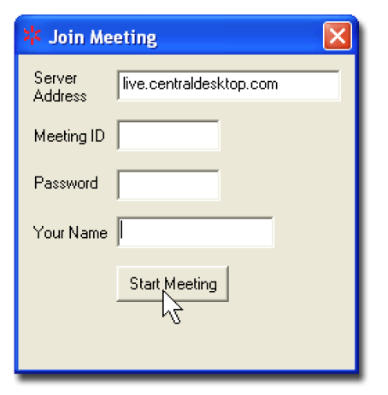
4. Click Start Meeting to join the web meeting.
5. The Central Desktop Console will appear on your screen when the meeting begins.
9/28/2006
Page 2 of 3

Attendee Quick Reference Guide

JOIN A MEETING FROM THE CENTRAL DESKTOP WEBSITE
Internet Explorer Users
1. Open an internet browser and go to http://www.centraldesktop.com/joinlive
2. Enter the Meeting ID and Password directly into the web form.
3. Click the “Join Meeting Now” to join the Web Meeting.
Non-Internet Explorer Users
1. Open an internet browser and go to http://www.centraldesktop.com/joinlive
2. Download the Web Meeting Client.
- Click Save and save the file to your Desktop, then launch the file.
(Launch the file by double-clicking the Join Meeting icon that now appears on your desktop)
-At the screen prompt, type “live.centraldesktop.com” into the Server Address field and enter
the Meeting ID and Password from the Email Invitation.
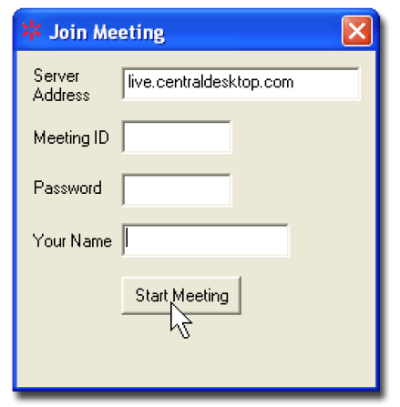
3. Click Start Meeting to join the web meeting.
4. The Central Desktop Console will appear on your screen when the meeting begins.
9/28/2006
Page 3 of 3

Attendee Quick Reference Guide
USING THE CONFERENCE CALL DIAL-IN NUMBER
Central Desktop Live provides a Telephone Conference Call service at no additional charge.
Note: Conference Call numbers are US phone numbers. International numbers are currently not provided.
After joining the Telephone Conference Call, you may press “6” on your touch-tone phone to mute (or unmute)
your line.
Press “#” to hear the number of callers on the line.

CENTRAL DESKTOP LIVE SYSTEM REQUIREMENTS
Supported Operating Systems: Windows XP, 2000 and 98
To Host Meetings you will need Internet Explorer v5.5 or higher.
To Join a Meeting you just need Windows XP, 2000 or 98.
We are working on additional Operating System support (including Mac and Linux), please stay tuned.

SUPPORT
For additional support please email us at support@centraldesktop-inc.com.
Organizer Quick Reference Guide

WHAT IS CENTRAL DESKTOP LIVE?
Central Desktop Live is an integrated Real-Time Web Conferencing solution that you can use to Host
Web Meetings through Central Desktop. It’s an easy way to Share Your Desktop Screen with other Team Members without ever leaving the comfort of Central Desktop.

SCHEDULING A MEETING
1. Login to Central Desktop and click the “Central Desktop Live” Tab
(Located on the Dashboard)
2. Select “Schedule a Web Meeting”.
3. When scheduling a meeting, if the Web Meeting pertains to a Central Desktop Workspace, select
the Workspace.
4. A Conference Call Dial in Number is provide at no additional charge, if you would like to use a
different conference dial in number, uncheck the box and enter the information into the
description area of the Web Meeting.
5. To add this Event to Microsoft Outlook Calendar, Invite other Attendees or to set a meeting
reminder in Outlook check the “Add this Event to My Outlook Calendar” box.
(Select “Open” at the prompt after the Event is scheduled.)
6. Click “Schedule Event”.
NOTE: WEB MEETINGS MAY ALSO BE SCHEDULED FROM THE “MY CALENDAR” TAB LOCATED ON THE DASHBOARD OR FROM ANY CALENDAR IN A WORKSPACE.

STARTING A SCHEDULED MEETING
1. Login to Central Desktop and click the “Central Desktop Live” Tab.
(Located on the Dashboard)
2. From the list of Scheduled Meetings, click the “Host Meeting” to start the Web Meeting.
(Note: Central Desktop Live Web Meetings Can Only Be Started in Internet Explorer. Attendees are not required to use Internet Explorer, only Hosts. Firefox and Mozilla support are slated for a Fall release.)
9/28/2006

Page 2 of 3
Organizer Quick Reference Guide
STARTING AN UNSCHEDULED MEETING (AD-HOC / IMPROMPTU MEETING)
From the Central Desktop Live Tab (On the Dashboard)
1. Login to Central Desktop and click the “Central Desktop Live” Tab
2. Click “Host a Web Meeting Now”.
3. Enter the email addresses of the Attendees you wish to invite and notify.
Be sure to check the “Include Conference Call Number” if you would like Central Desktop to provide you with a Conference Dial in Number (there is no charge for this additional service).
4. The Central Desktop Live Console will appear in the right hand side of your screen and your Web Meeting will begin.
From Inside a Central Desktop Workspace
1. From the Member’s Block in the Navigation Bar of the Workspace, check the box next to each Member that you would like to invite to the Web Meeting and click the “Web Meeting” Button.
2. Invite additional Attendees (even non-Central Desktop users) to the Web Meeting by entering
their email address at the pop-up screen and clicking “Send Email Invitations and Start Meeting.”
3. The Central Desktop Live Console will appear in the right hand side of your screen and your Web
Meeting will begin.

USING THE CONFERENCE CALL DIAL-IN NUMBER
Central Desktop Live provides a Telephone Conference Call service at no additional charge.
Note: Conference Call numbers are US phone numbers. International numbers are currently not provided.
To Join the Conference Call as the Organizer (Presenter), press the star key ( * ) followed by the Meeting Access Code. The call begins when the first caller arrives into the conference.
The default mode of the Conference Call is Conversation Mode.
At any time during a conference, the conference Organizer can switch between Conversation Mode, Q&A Mode and Presentation Mode by pressing the “7” key on their telephone keypad.
􀂾 Conversation Mode provides an open, un-muted conference in which all attendees can speak freely.
􀂾 Presentation Mode automatically mutes attendees of the conference call. This mode works best with larger groups to reduce background noise.
􀂾 Q & A Mode allows Attendees to un-mute themselves, permitting a ‘question and answer’ or interactive session to be held during the conference call. While in Q & A Mode, Attendees can press “6” on their telephone keypad to mute or un-mute their lines.
9/28/2006

Page 3 of 3
Organizer Quick Reference Guide
Other Organizer Features Include:
􀂾 Press ( # ) to hear the number of callers on the line.
􀂾 Press ( 4 ) to hear the help menu.
􀂾 Press ( 5 ) to Lock or Unlock the Conference.
(When locked, no additional Attendees can join the conference)
􀂾 Press ( 6 ) to Mute or Un-Mute Your Line.
􀂾 Press ( 9 ) to Enable or Disable the Entry and Exit Chimes.

CENTRAL DESKTOP LIVE SYSTEM REQUIREMENTS
Supported Operating Systems: Windows XP, 2000 and 98
To Host Meetings you will need Internet Explorer v5.5 or higher.
To Join a Meeting you just need Windows XP, 2000 or 98.
We are working on additional Operating System support (including Mac and Linux), please stay tuned.

SUPPORT
For additional support please email us at support@centraldesktop-inc.com.

CENTRAL DESKTOP LIVE CONSOLE
Highlight the participant’s
name in the list and click
“Assign Presenter” to
change Presenter’s and view
the Participant’s Screen.
Enables Presenter to
“scribble” on the screen with
the mouse. Good for
highlighting and pointing.
Ends Meeting.
Highlight the participant’s
name in the list and click
“Assign Controller” to grant
them rights to control the
Presenter’s mouse and
keyboard.
Opens the Presenter’s local
version of Microsoft Paint.
Easily Invite Others to Join
Web Meeting.
Presentation Status Console

Organizer Quick Reference Guide
WHAT IS CENTRAL DESKTOP LIVE?
Central Desktop Live is an integrated Real-Time Web Conferencing solution that you can use to Host
Web Meetings through Central Desktop. It’s an easy way to Share Your Desktop Screen with other
Team Members without ever leaving the comfort of Central Desktop.

SCHEDULING A MEETING
1. Login to Central Desktop and click the “Central Desktop Live” Tab
(Located on the Dashboard)
2. Select “Schedule a Web Meeting”.
3. When scheduling a meeting, if the Web Meeting pertains to a Central Desktop Workspace, select
the Workspace.
4. A Conference Call Dial in Number is provide at no additional charge, if you would like to use a
different conference dial in number, uncheck the box and enter the information into the
description area of the Web Meeting.
5. To add this Event to Microsoft Outlook Calendar, Invite other Attendees or to set a meeting
reminder in Outlook check the “Add this Event to My Outlook Calendar” box.
(Select “Open” at the prompt after the Event is scheduled.)
6. Click “Schedule Event”.
NOTE: WEB MEETINGS MAY ALSO BE SCHEDULED FROM THE “MY CALENDAR” TAB
LOCATED ON THE DASHBOARD OR FROM ANY CALENDAR IN A WORKSPACE.

STARTING A SCHEDULED MEETING
1. Login to Central Desktop and click the “Central Desktop Live” Tab.
(Located on the Dashboard)
2. From the list of Scheduled Meetings, click the “Host Meeting” to start the Web Meeting.
(Note: Central Desktop Live Web Meetings Can Only Be Started in Internet Explorer. Attendees are not
required to use Internet Explorer, only Hosts. Firefox and Mozilla support are slated for a Fall release.)
9/28/2006
Page 2 of 3

Organizer Quick Reference Guide

STARTING AN UNSCHEDULED MEETING (AD-HOC / IMPROMPTU MEETING)
From the Central Desktop Live Tab (On the Dashboard)
1. Login to Central Desktop and click the “Central Desktop Live” Tab
2. Click “Host a Web Meeting Now”.
3. Enter the email addresses of the Attendees you wish to invite and notify.
Be sure to check the “Include Conference Call Number” if you would like Central Desktop to
provide you with a Conference Dial in Number (there is no charge for this additional service).
4. The Central Desktop Live Console will appear in the right hand side of your screen and your Web
Meeting will begin.
From Inside a Central Desktop Workspace
1. From the Member’s Block in the Navigation Bar of the Workspace, check the box next to each
Member that you would like to invite to the Web Meeting and click the “Web Meeting” Button.
2. Invite additional Attendees (even non-Central Desktop users) to the Web Meeting by entering
their email address at the pop-up screen and clicking “Send Email Invitations and Start Meeting.”
3. The Central Desktop Live Console will appear in the right hand side of your screen and your Web
Meeting will begin.

USING THE CONFERENCE CALL DIAL-IN NUMBER
Central Desktop Live provides a Telephone Conference Call service at no additional charge.
Note: Conference Call numbers are US phone numbers. International numbers are currently not provided.
To Join the Conference Call as the Organizer (Presenter), press the star key ( * ) followed by the Meeting
Access Code. The call begins when the first caller arrives into the conference.
The default mode of the Conference Call is Conversation Mode.
At any time during a conference, the conference Organizer can switch between Conversation Mode,
Q&A Mode and Presentation Mode by pressing the “7” key on their telephone keypad.
􀂾 Conversation Mode provides an open, un-muted conference in which all attendees can speak
freely.
􀂾 Presentation Mode automatically mutes attendees of the conference call. This mode works best
with larger groups to reduce background noise.
􀂾 Q & A Mode allows Attendees to un-mute themselves, permitting a ‘question and answer’ or
interactive session to be held during the conference call. While in Q & A Mode, Attendees can
press “6” on their telephone keypad to mute or un-mute their lines.
9/28/2006
Page 3 of 3

Organizer Quick Reference Guide
Other Organizer Features Include:
􀂾 Press ( # ) to hear the number of callers on the line.
􀂾 Press ( 4 ) to hear the help menu.
􀂾 Press ( 5 ) to Lock or Unlock the Conference.
(When locked, no additional Attendees can join the conference)
􀂾 Press ( 6 ) to Mute or Un-Mute Your Line.
􀂾 Press ( 9 ) to Enable or Disable the Entry and Exit Chimes.

CENTRAL DESKTOP LIVE SYSTEM REQUIREMENTS
Supported Operating Systems: Windows XP, 2000 and 98
To Host Meetings you will need Internet Explorer v5.5 or higher.
To Join a Meeting you just need Windows XP, 2000 or 98.
We are working on additional Operating System support (including Mac and Linux), please stay tuned.

SUPPORT
For additional support please email us at support@centraldesktop-inc.com.

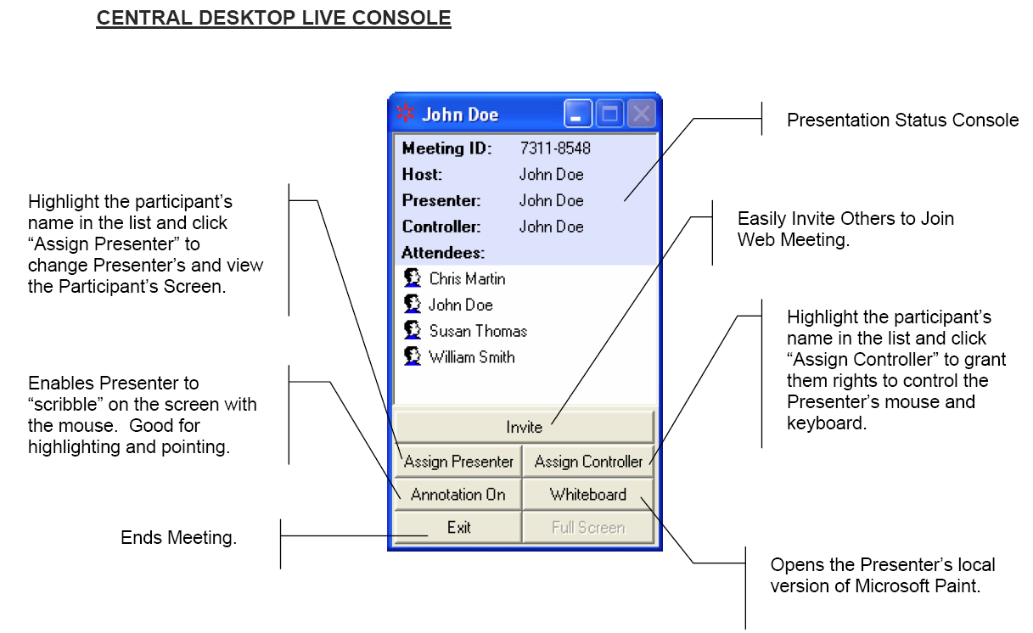
CENTRAL DESKTOP LIVE CONSOLE
Highlight the participant’s
name in the list and click
“Assign Presenter” to
change Presenter’s and view
the Participant’s Screen.
Enables Presenter to
“scribble” on the screen with
the mouse. Good for
highlighting and pointing.
Ends Meeting.
Highlight the participant’s
name in the list and click
“Assign Controller” to grant
them rights to control the
Presenter’s mouse and
keyboard.
Opens the Presenter’s local
version of Microsoft Paint.
Easily Invite Others to Join
Web Meeting.
Presentation Status Console

