UI Flow 2
Step 1 2
Step 2 3
Step3 3
Step4 4
Step5 6
Code object lists 7
Step1 7
Step2 8
Step3 9
Step4 10
Step5 11
Database 12

UI Flow
The following steps are the User Interface flow for adding a service(files service) :

Step 1 - Detail entry step :
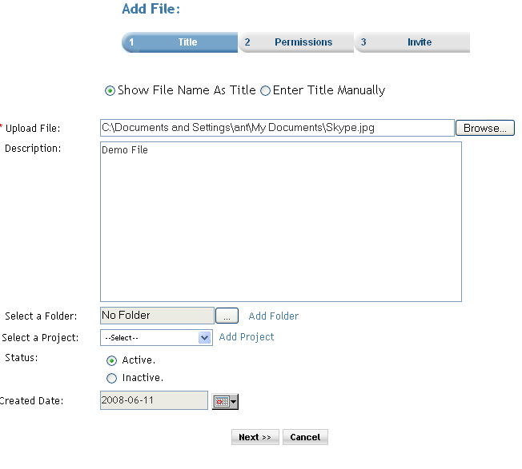
Description : In Step1 the user enters the service name and the description for the service. There is a ‘select a folder’ option, if the user wants to save the service in a particular service folder. There is a ‘select a project’ option, if the user wants to assign the service to a particular project. There are option button to set the status of the newly added service. On click of the next button will take the user to Step2.

Step 2 - Set permission step :
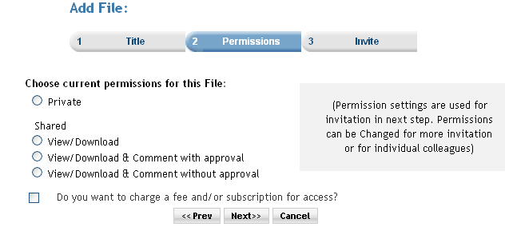

Description : In Step2 the user is able to set the permission for the service. And the premium user can also set the subscription for the service. When the ‘Do you want to charge a fee and/or subscription for access?’ checkbox is selected then the next button click takes the user to the step3. And if the checkbox is not checked then the next button click takes the user directly to step5.

Step3 – Set Subscription step :

In Step3 there are two options available as mentioned further :
- The user can set same subscription for all the permission levels.
Step 3a.
- The user can set different subscription for different permissions.
Step 3b.

Step 3a - Set common subscription step :
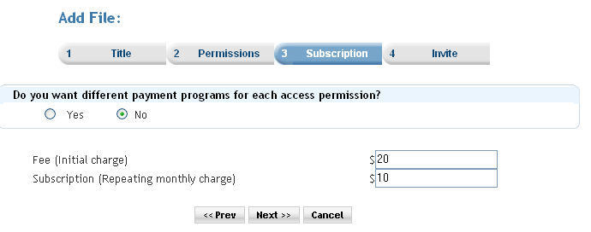
Description : In Step3a the user can insert the fee(initial charge) and the repeating monthly charge only once and the charges will apply to all the service permissions. And when the next button is clicked then the user is taken to Step4(step 4a).

Step 3b – Set different subscription for different permission step :

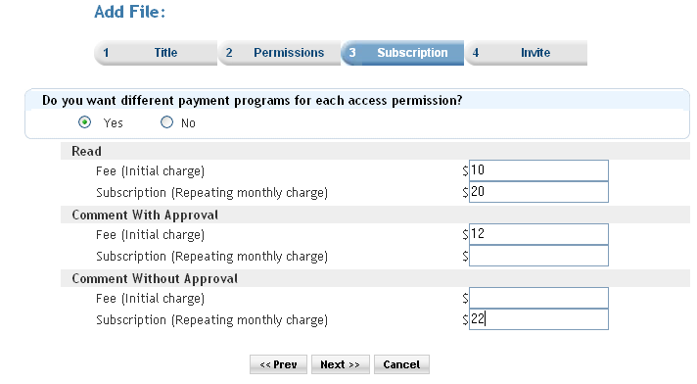

Description : In Step3b the user can insert the fee(initial charge) and the repeating monthly charge for al the service permissions. And when the next button is clicked then the user is taken to Step4(step 4b).

Step4 – In step 4 the calculated subscriptions are displayed to the user. Actually the commission for the site is deducted and the step shows the amount that the user will receive.

Step 4a – Calculated subscription display :

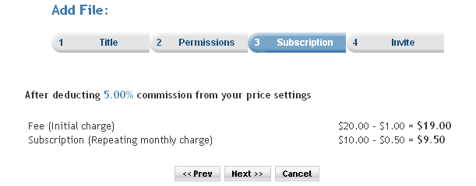

Description : In Step 4a the user is shown the deductions and the amount that the user will receive.

Step 4b – Calculated subscription display :
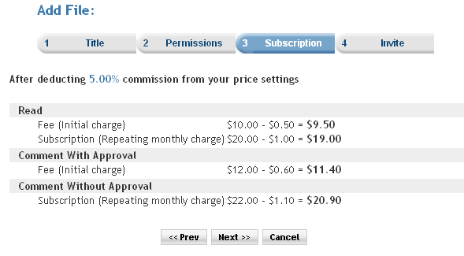

Description : In Step 4b the user is shown the deductions and the amount that the user will receive. On next button click the user will be taken to Step5 (Invitation step).

Step5 – Service invitation step.

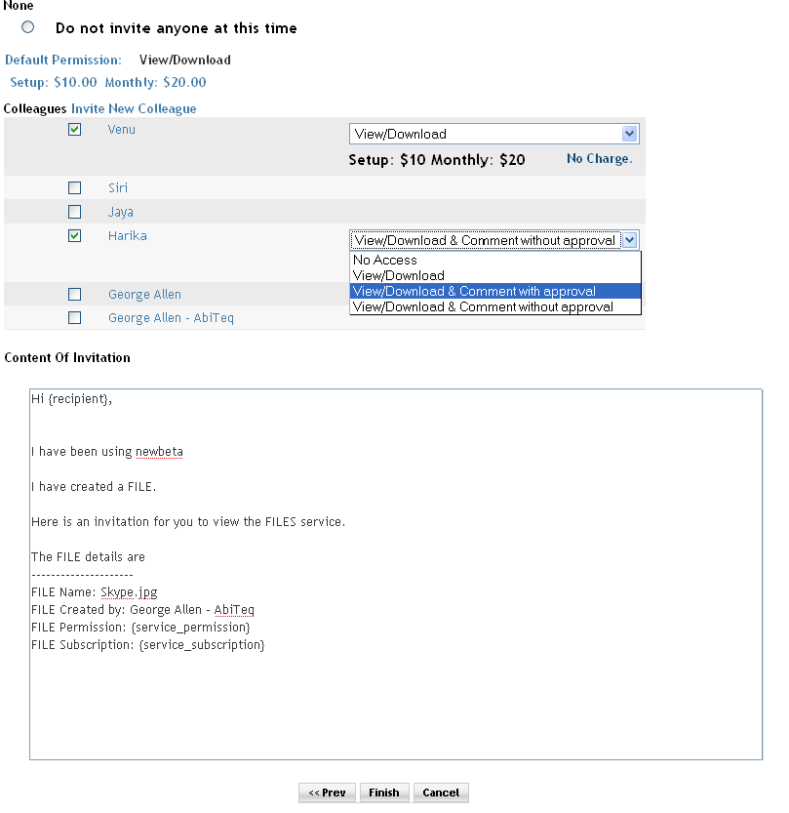

Description : In Step5 the list of colleagues of the user is displayed. The user can select members to invite for the service from these colleagues. The user can set different permissions for different colleagues. The user can invite new members through the ‘invite new colleague link’. Similarly, the user can invite groups and organizations.

The above steps are of the files service. The wizard steps vary as per the services. As in the poster service there are more than five steps and in Event service there are only three services.

Code object lists

Step1 : filesetup.php

In first step on the click of the next button the form action redirects to the same php(filesetup.php). On submit it is checked that all the needed information is filled in right manner.
The allocated space is been checked and if the user has exceeded the allocated space then a mail is sent to the user regarding it. The uploaded file is copied to the temporary directory.

The first step for all the services start from the setup page as for forum it is forumsetup, for blogs service it is blogsetup, and so on.

All the second step settings are been done.

  - Classes : The ‘PHPMailer’ class is been used to send a mail to the user if the allocated space is exceeded.
  - Includes : Mainly includes the following files :
files.inc.php
invitation.inc.php
colleagues.inc.php
mailer/class.phpmailer.php
mailer/class.smtp.php
  - Functions : Following are the functions which are mainly used :
moveUploadedFileToTempDir() : The function moves the uploaded file to temporary directory.
sendMessage() : It is used to send message.
  - Graphics : The css mainly used is style_blue.css
  - Flash : No flash is used.
  - Ajax : No ajax used.
  - Javascript : files.js
  - Pages : filesetup.php

Step2 : filesetup.php

The second step varies for different services. As for the poster service it has options to select on the first step and related to that the second step is executed.

In the second step there is a check box for setting subscriptions. The check box is only accesscible to premium members. if the check is checked then it is redirected to the service prices step(Step3 / service_prices.php) and if it is kept unchecked the it gets redirected directly to the service invite step(Step5 / service_invite.php).

In this step an object of the Files class is created which gets all the file information on the previous page.

Then a file is created. And the related data is stored in the relative table in the database. using the createFile function. The file object is passed to the function which contains all the data related to the created file.

  - Classes : An object of the ‘Files’ class created. Say ‘fileobject’.
The fileobject contains all the data related to the file service.
  - Includes : Mainly includes the following files :
      - files.inc.php
      - invitation.inc.php
      - colleagues.inc.php
      - mailer/class.phpmailer.php
      - mailer/class.smtp.php
  - Functions : Following are the functions which are mainly used :
      - createFile() : the create file function is passed the fileobject as a parameter and in this function a record is added to service table here ‘filemaster’ table.
  - Graphics : The css mainly used is style_blue.css
  - Flash : No flash is used.
  - Ajax : No ajax used.
  - Javascript : files.js
  - Pages : filesetup.php

Step3 : service_prices.php

In the third step, there are two options available with the user, ‘yes’ & ‘no’. With ‘yes’ option, user can set different subscriptions for different permission level, with ‘no’ option, user can set same subscription for all permission levels.

On the click of the next button, the subscription price calculation is performed and the form action redirects to the same php(service_prices.php).

In this step , the subscription prices values are taken , that are entered by the user .
  - Classes : No classes used.
  - Includes : Mainly includes the following files :
      - subscriptions.inc.php
      - services.inc.php
      - invitation.inc.php
      - members.inc.php
      - payments.inc.php
  - Functions : No as such function are used in the third step.
  - Graphics : The css mainly used is style_blue.css
  - Flash : No flash is used.
  - Ajax : No ajax used.
  - Javascript : No js included.
  - Pages : service_prices.php.

Step4 : service_prices.php

In the fourth step, the calculated subscription price value is displayed on the same php(service_prices.php). Some percentage of the subscription value is deducted as tax.
On the click of the next button, the original(not the calculated one) subscription price value is stored into the databases in the ‘subscription_serviceprices’ table and the form is submitted. It gets redirected to the service_invite.php page(step5).

  - Classes : No classes used.
  - Includes : Mainly includes the following files :
      - subscriptions.inc.php
      - services.inc.php
      - invitation.inc.php
      - members.inc.php
      - payments.inc.php
  - Functions : setServicePrice() : This function is called only once if the default subscription is set. And if different subscriptions are set for different permissions the the function is called multiple times. The details of the service subscriptions are passed as parameters to the function. In this function record is added to the table ‘subscription_serviceprices’ with appropriate record.
  - Graphics : The css mainly used is style_blue.css
  - Flash : No flash is used.
  - Ajax : No ajax used.
  - Javascript : files.js
  - Pages : service_prices.php

Step5 : service_invite.php

In the fifth step , the user has an option to invite new colleague. If the user doesn’t want to send invitation, then user can check the “ Do not invite anyone at this time “ radio button and click finish.

The user can invite new colleague by clicking on ‘Invite New Colleague’ , which will redirect to ‘invite.php’ page. The user also can invite new ‘Groups’ , ’Organization’ or from existing colleagues, Groups, Organization by checking the appropriate checkboxes.

On the click of the ‘Finish’ button , all the information (data record) collected through the process is stored into the database in the relevant table, invitation will be sent to respective colleague only if the user had chosen to invite and the form is submitted and redirected to Service home page.

  - Classes : No classes used.
  - Includes : Mainly includes the following files :
      - subscriptions.inc.php
      - services.inc.php
      - invitation.inc.php
      - members.inc.php
      - payments.inc.php
  - Functions : addInvitationMssg() :
In this function a record is added in the ‘memberinvitationmessage’ table.
postInvitation() : This function is called as many times as the number of the colleagues invited. In this function records are added to the ‘memberinvitations’ table where the invitation message and other such data is stored. Then the invitation is send to the invitees through the same function.
  - Graphics : The css mainly used is style_blue.css
  - Flash : No flash is used.
  - Ajax : No ajax used.
  - Javascript : files.js, invite.js
The page consist of good java script as all the functions such as permission drop down, change of the UI setting the correct subscription is done using java scripting.
  - Pages : service_invite.php.

For every service the wizard steps differ as for the poster service there are more than five steps and in Event service there are only three services.

Database
        - Databases : No change at the database level.
        - Tables : Records were added in the following tables
Filemaster : In the second step(filsetup.php) here.
For Forums service ‘forums’ table and for Blogs service ‘blogs’ table and so on.
In this way records are added to the service details table for all the services.

subscription_serviceprices : In the fourth step(service_prices.php) the records are added. Common for all the services.
memberinvitationmessage : In the fifth step(service_invite.php) the records are added. Common for all the services.
memberinvitations : In the fifth step(service_invite.php).
common for all the services.
        - Fields : No change.

