UI Flow 2
Header 2
Batch File Home page 2
Batch File Add wizard 3
Wizards 4
Code object lists 4
Classes 4
Includes 5
Functions 5
Flash 6
Ajax 6
Javascript 6
Pages 6
Database 6
Databases 6
Tables 7
Fields 7

Batch File Service

UI Flow

Header
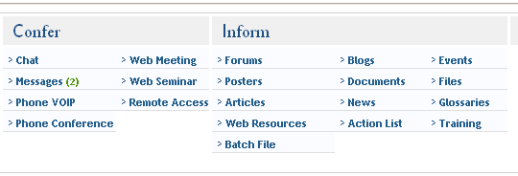

Added the ‘Batch File’ link in the header under the Inform services tab for the service.
On click of the link the page will be redirected to the Batch file home page (batchfile.php).

Batch File Home page

The home page shows all the list of ‘Batch files’
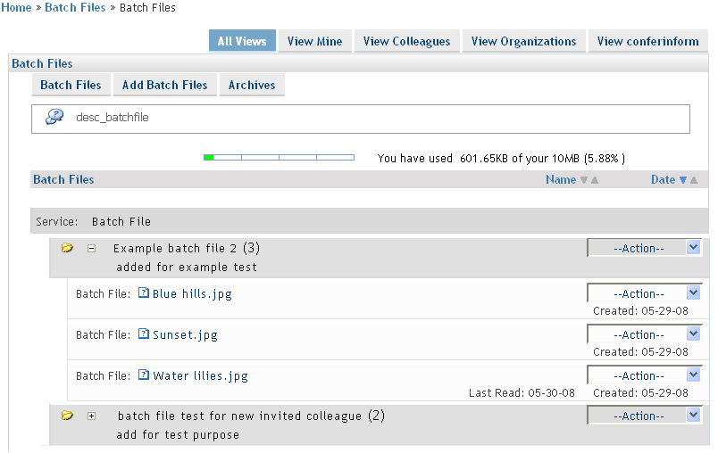

The current users batchfiles are shown on the home page and under each batch file the list of files belonging to the batch file are listed. Batch files as well as the file names are links(anchor tag is used). When the batchfile name link is clicked then the page is redirected to the Batch file detail page and also a download popup window appears and gives the user option to download the whole batchfile in a compressed format. When the file name links are clicked then the page is redirected to the file details page and download popup window appears and gives the user option to download the file.

Batch File Add wizard

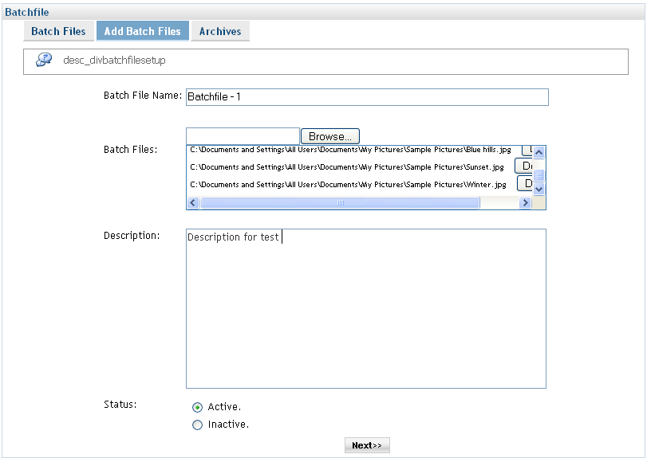

Wizards
    - Adding : A new type of wizard is added where the whole add wizard is carried out using java script and only once form submit is done where all the data is collected and the service is added through on submit(rather than submitting form on each step of the wizard as in other service wizards.) The wizard is similar as to the add file wizard. The only difference is that in the batch file add wizard there are options to upload multiple files. And all the uploaded files are stored under a single folder.

Code object lists
Classes : spectreZip
zipfile
The classes are used to zip the batchfile(folder) for downloading.

Includes :
    - The following include files were added :
batchfile.inc.php
zip.lib.php
spectre.zip.php
batchfile.inc.php is the main include added for the batchfile service. The zip.lib.php and spectre.zip.php are included for compressing the folder and for downloading the compressed folder.
ii. The following files were edited :
common.inc.php
constants.inc.php
services.inc.php
invitation.inc.php
themes_services.inc.php
templating.inc.php
themes.inc.php

Functions :
The main functions for the add batch file wizard are :
moveUploadedFileToTempDir() : The function uploads batchfile(folder/batch of files) to an directory on the server and then a record for each file is added to service table here ‘batchfile’ table and a single record is added to the batchfilefolder table with the details of the folder.
setServicePrice() : This function is called only once if the default subscription is set. And if different subscriptions are set for different permissions the the function is called multiple times. The details of the service subscriptions are passed as parameters to the function. In this function record is added to the table ‘subscription_serviceprices’ with appropriate record.
addInvitationMssg() :
In this function a record is added in the ‘memberinvitationmessage’ table.
postInvitation() : This function is called as many times as the number of the colleagues invited. In this function records are added to the ‘memberinvitations’ table where the invitation message and other such data is stored. Then the invitation is send to the invitees through the same function.

Flash : No Flash were added.
Ajax : Did not use ajax.
Javascript :
i. The following java script files were added
binvite.js
multifile_compressed.js
ii. The following java script files were modified
files.js
Pages : Following are the added pages which are in site folder:
batchfile.php
my_batchfile.php
addbatchfile.php
batchfile_links.php
divbatchfilesetup.php
batchfile_invite.php
batchfile_prices1.php
batchfile_prices2.php
batchfilesetup.php
view_bfolder.php
show_bfile.php
batchfiles_create.php
batchfilefolder_setup.php
getuploadedbfile2.php
getuploadedbfolder2.php

Database
Databases : No changes at the database level.
Tables : The following two tables were added
batchfile
batchfilesfolder
Fields : The fields of the added tables are as follows:
i. Table batchfile :
BFILEID
BFILENAME
BFILETYPE
BFILEDESCRIPTION
BFILEUNIQUENAME
BFFID
BFILECREATEDBY
BFILECREATEDON
BFILESTATUS
BFILEVISIBLESTATUS
BFILEPERMISSIONS
BFILEPUBLICSTATUS
OMID

ii. Table batchfilesfolder :
BFFID
BFFNAME
BFFDESC
BFFCREATEDBY
BFFCREATEDON
BFFSTATUS
BFFVISIBLESTATUS
BFFPERMISSIONS
BFFPARENTID
BFFLEVEL
BFFPUBLICSTATUS
OMID
BFFOLDERUNIQUEID

