User Interface 2
Code object lists 2
Classes 2
Includes 2
Functions 2
Graphics 2
Flash 3
Ajax 3
Pages 3
Database 3
Databases 3
Tables 3
Fields 3

Folder Tree Structure

User Interface

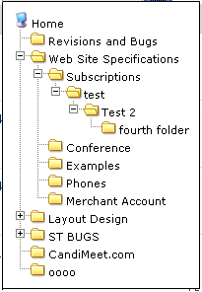
The view of the folder tree structure is basically a Div in which the tree structure is displayed.

Code object lists
Classes : none.
Includes : Mainly the inculde file is services.inc.php
In which the addServiceFoldersToTreebox() function is written.

Functions :
addServiceFoldersToTreebox() : The function is used to return the structure of the folder present for a particular service related to a user. The function takes the service type(MODULE_TYPE_FORUM, MODULE_TYPE_FILES…), the master category(upper level folders ID), the category id(folder id), and a counter to maintain the levels as parameters. The function is recursive in nature and iterates for all the levels of the folders.

Graphics : A div was added to display the folder tree structure. ‘tree.css’ is used is mainly used for the graphic for the tree folder div.

Flash : No flash.
Ajax : No ajax used.
Javascript : The java script file ‘tree.js’ was used to put the folder on the tree.
Used java script to trap events such onclick, onblur to obtain results. The basic functions for hiding and showing the div and to get the values of the selected folder are written on all the php’s where the folder tree structure is displayed(filesetup.php, forumsetup.php, blogsetup.php…)
Function such as
Pages : Edited in every php where the folder tree structure has to be displayed (filesetup.php, forumsetup.php, blogsetup.php…).

Database
Databases : No change.
Tables : No change.
Fields : No change.

