User Interface 2
Code object lists 2
Classes 2
Includes 2
Functions 2
Graphics 3
Flash 4
Ajax 4
Javascript 4
Database 4
Databases 4
Tables 4
Fields 4

Drop down Menu Sublinks

User Interface

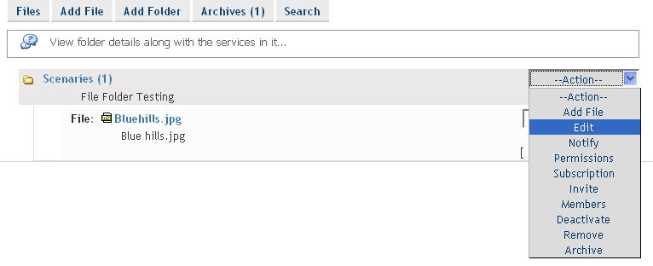

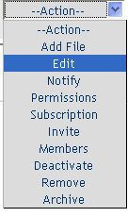
On the home page of all the services the services and the service folders are displayed. For the services and the service folder the menu is shown in a drop down box format. There are options to edit, add service, notify, invite etc on the drop down menu.

Code object lists
Classes :None.
Includes : Major changes were done in themes_services.inc.php
Functions : The code under the following Functions was edited to perform the task for Service Menus in themes_services.inc.php:
      - getForumSubLinks()
      - getBlogSubLinks()
      - getPosterSubLinks()
      - getEventSubLinks()
      - getArticleSubLinks()
      - getGlossaryTermSubLinks()
      - getNewsSubLinks()
      - getFileSubLinks()
      - getLinkSubLinks()
      - getDocumentSubLinks()
      - getTrainingSubLinks()
      - getActionListSubLinks()

Add also the code under the switch cases for all services was been edited in themes_services.inc.php for uplying the changes to the service folder menu.
The above mentioned function return the options for the drop down menu and the the are inserted to the select box.

Graphics : The look of the links earlier was a string of Href separated by pipes and now the links are given in drop down box.
Edited the following tpl’s and css for the same.
- actionlists_folder_nlevel.tpl
- actionlists_service_nlevel.tpl
- articles_folder_nlevel.tpl
- articles_service_nlevel.tpl
- blogs_folder_nlevel.tpl
- blogs_service_nlevel.tpl
- documents_folder_nlevel.tpl
- documents_service_nlevel.tpl
- events_folder_nlevel.tpl
- events_service_nlevel.tpl
- files_folder_nlevel.tpl
- files_service_nlevel.tpl
- forums_folder_nlevel.tpl
- forums_service_nlevel.tpl
- glossaries_folder_nlevel.tpl
- glossaries_service_nlevel.tpl
- news_folder_nlevel.tpl
- news_service_nlevel.tpl
- posters_folder_nlevel.tpl
- posters_service_nlevel.tpl
- training_folder_nlevel.tpl
- training_service_nlevel.tpl
- webresources_folder_nlevel.tpl
- webresources_service_nlevel.tpl

Edited the following tpls and PHP for the view all menu.

- actionlist_home_title.tpl
- article_home_title.tpl
- blog_home_title.tpl
- document_home_title.tpl
- event_home_title.tpl
- file_home_title.tpl
- forum_home_title.tpl
- glossary_home_title.tpl
- link_home_title.tpl
- news_home_title.tpl
- poster_home_title.tpl
- training_home_title.tpl
and
- view_folder.php

Edited the CSS style_blue.css added two Classes :

- selectbox-dark
- selectbox

Flash : No flash
Ajax : No ajax used.
Javascript : Added two Functions to the files.js file. For the purpose of redirecting to the desired pages.
1) checkflinks()
2) checklink()

Database
Databases : No change.
Tables : No change.
Fields : No change.

