User Interface 2
Code object lists 2
Classes 2
Includes 2
Functions 2
Graphics 4
Flash 4
Ajax 4
Javascript 4
Pages 4
Database 4
Databases 4
Tables 4
Fields 4

Home Page

User Interface
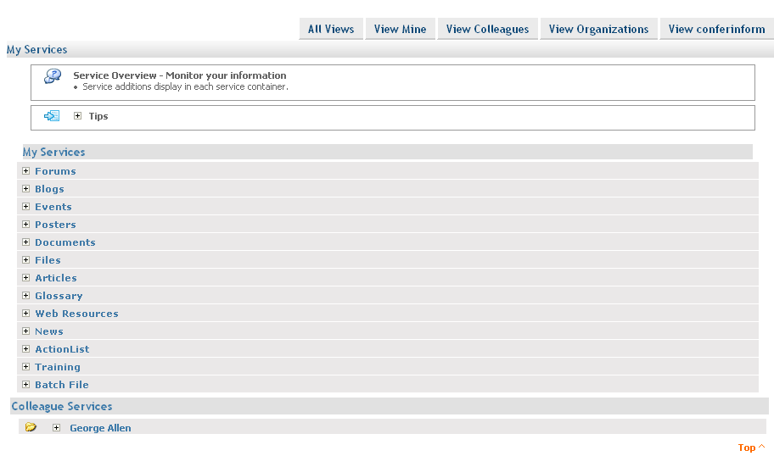
On the site home page when a user logs in the list of the services of the user are shown. Even the colleagues and the organization services shown. Whwn clicked on the ‘view colloeagues’ tab only the colleagues services are shown and so on.

Code object lists
Classes : None.
Includes : Some functions in the service inc’s were modified and even some functions were added to the inc files of the services(forums.inc.php, files.inc.php, blogs.inc.php,etc.).
Functions : The follow functions were added to the respected service inc’s.
templating.inc.php :
Added the functions -
1. getAllColleagueServices() : The function returns the colleagues services.

- getAllOrganizationServices(): The function returns the organization services.

forums.inc.php : getForumsAndFoldersForUser()
hasForumsAndfolders()
blogs.inc.php : getBlogsAndFoldersForUser()
hasBlogsAndfolders()
events.inc.php : getEventsAndFoldersForUser()
hasEventsAndfolders()
posters.inc.php : getPostersAndFoldersForUser()
hasPostersAndFolders()
document.inc.php : getDocumentsAndFoldersForUser()
hasDocumentsAndfolders()
files.inc.php : getFilesAndFoldersForUser()
hasFilesAndFolders()
article.inc.php : getArticlesAndFoldersForUser()
hasArticlesAndfolders()
glossary.inc.php : getGlossaryAndFoldersForUser()
hasGlossaryAndfolders{}
links.inc.php : getLinksAndFoldersForUser()
hasLinksAndfolders()
news.inc.php : getNewsAndFoldersForUser()
hasNewsAndfolders()
actionlist.inc.php : getActionListAndFoldersForUser()
hasActionListAndfolders()
training.inc.php : getTrainingAndFoldersForUser()
hasTrainingAndfolders()
batchfile.inc.php : getBFileForUser()
hasBFilesAndFolders()
In the above mentioned functions the getForumsAndFoldersForUser(), getBlogsAndFoldersForUser(),getEventsAndFoldersForUser() etc functions are used to get the services for the member id which is passed as a parameter to these functions. Ant the other functions such as hasForumsAndfolders(),
hasBlogsAndfolders(), hasEventsAndfolders() etc are used to check whether there exist services for the respected user. Member id is passed as a parameter to the functions.

Graphics : Changed the containers on the home page to list.
CSS Changes :
style.css
Flash : No flash.
Ajax : No ajax used.
Javascript : Java script functions are used to show or hide the list of the files on the click on the ‘+’ or the ‘–‘ image respectively.

Pages : The following file were added :
1) home_include.php : For displaying ‘My services’.
2) home_include_colleagues.php : For displaying colleagues services.
3) home_include_organization.php : For displaying organization services.

Database
Databases : No change
Tables : No change
Fields : No change

