User Interface 2
Code object lists 2
Classes 2
Includes 2
Functions 2
Graphics 3
Flash 3
Ajax 3
Javascript 3
Pages 3
Database 3
Databases 3
Tables 3
Fields 3

Member List task

User Interface (Display)

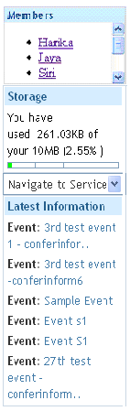
In the right menu the list of members is displayed on the details page for the services. And the order of the right menu option windows was also changed the sequence for the right menu is as follows:
- Members tab(it is only displayed for the service details page)
- Storage
- Navigate to service option
- Latest information

Code object lists
Classes : None.
Includes : No include files were edited.
Functions : Used the function getServiceInvitationsRight() to get the invited members for the service. The function gets records from the ‘Memberinvitations’ table by checking for the combination of created by memberid, service type and the service id.

Graphics : Added the member div in the right menu on service details page for all services.
Flash : No flash.
Ajax : No ajax used.
Javascript : No javascript used.
Pages : The following file were modified/added :
1) member_list.php(added) :
Included the member_list.php file in all the service details page as mentioned below for displaying the member list div.

2) article_detail.php
3) glossary_terms.php
4) news_detail.php
5) project.php
6) show_document.php
7) show_file.php
8) show_training.php
9) show.php
10) forum_reply.php
11) view_action.php

Database
Databases : No change
Tables : No change
Fields : No change

