UI Flow 2
Step 1 2
Step 2A 3
Step 2B 3
Step 2C 4
Step 3 4
Step 4 5
Code object lists 6
Step1 : 6
Step2 & 3 7
Step4 8
Database 9

UI Flow
The following steps are the User Interface flow for adding a Poster service :

Step 1 - Detail entry step :

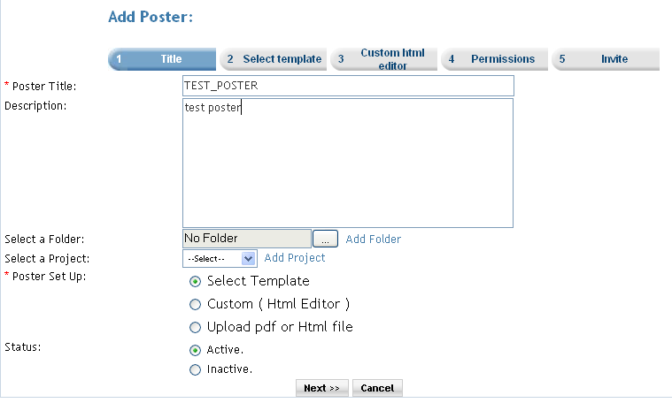

Description : In this step the user enters the name of the poster, the target poster(if needed), the status of the poster ant mainly selects the option of how to create the poster.
There are 3 ways of creating poster :
- Select Template : There are predefined templates present so that the user can select from those templates to create the poster. When this option is selected the user is taken to Step2A screen.
- Custom(Html Editor) : When this option is selected the user gets a blank html editor to edit and create the poster. On clicking ‘next’ button the user is taken to the step2B screen.
- Upload pdf or Html file : If this option is selected the user can upload an existing pdf file or html file and that file will be treated as the poster. If this is the selected option the on click of the Next button the user is taken to the Step2C screen.

Step 2A
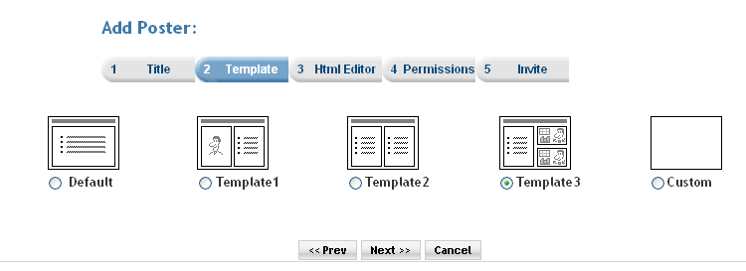

Description : The user can select from the above templates as in the above figure the user has select the Template3 option. Then on clicking the next button the user will be redirected to a page on which the selected template will be shown in a html editor and the user can make use of the selected template to create the folder. The ser is taken to Step3 screen on click of the Next Button.

Step 2B
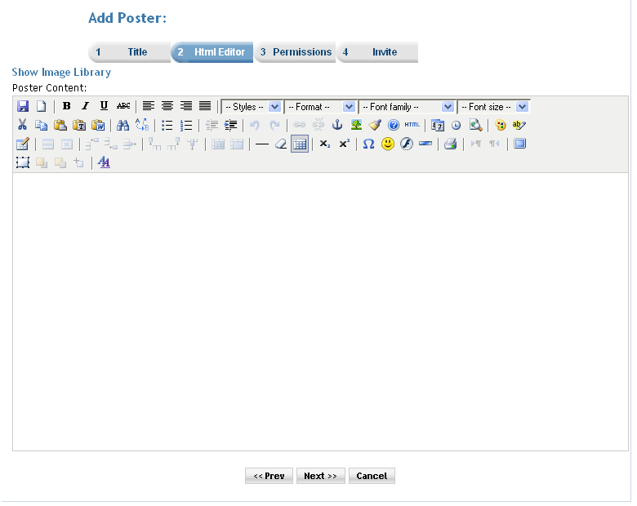

Description : The user can use/add components available here and create a poster of his/her own. The user is sent to the permissions page(step 4) on click of the next button.

Step 2C
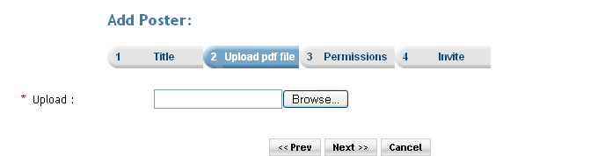
Description : The user can upload an existing PDF or Html file to the server and use that file and create a poster. The user is redirected to the permissions page(step 4) on click of the next button.

Step 3

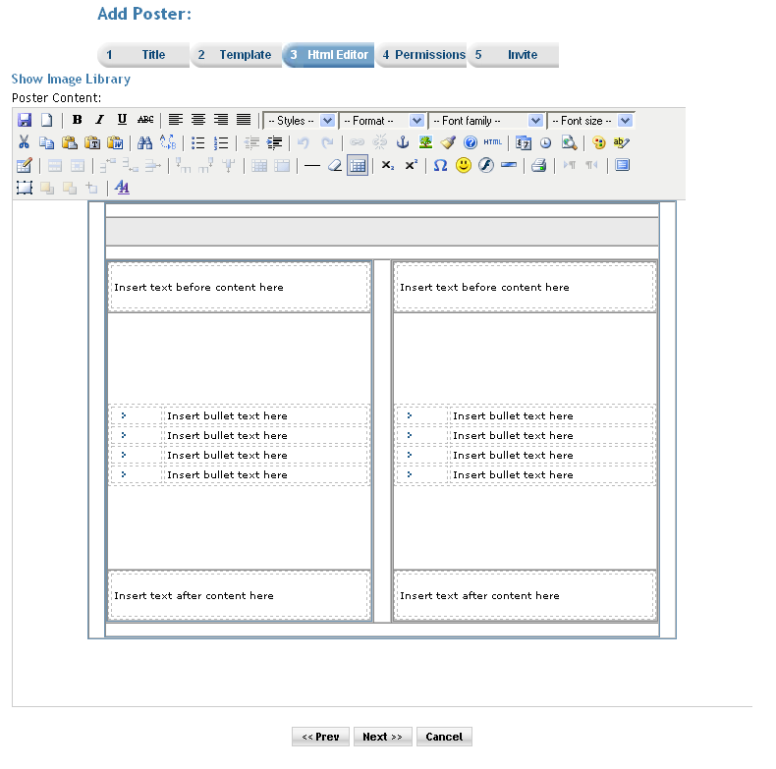
Description: Here the user had selected the Template3 option so the template is inserted into the html editor and is available to edit. In this way the user can use the template to create poster. On click of the next button the user is taken to the permissions page(step 4).

Step 4

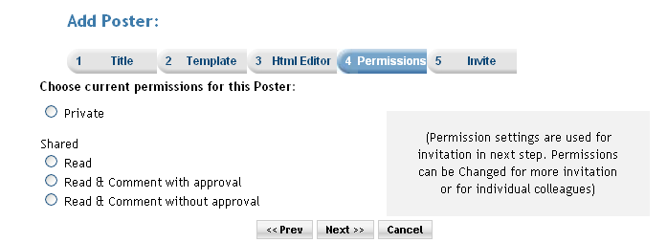

Description : In this Step user is able to set the permission for the service. And the premium user can also set the subscription for the service. When the ‘Do you want to charge a fee and/or subscription for access?’ checkbox is selected then the next button click takes the user to the subscription page. And if the checkbox is not checked then the next button click takes the user directly to invitation page.

Code object lists

Step1 : (createposter.php)

In this step the user enters the name of the poster, the target poster(if needed), the status of the poster ant mainly selects the option of how to create the poster.
There are 3 ways of creating poster :
- Select Template : There are predefined templates present so that the user can select from those templates to create the poster.
- Custom(Html Editor) : When this option is selected the user gets a blank html editor to edit and create the poster.
- Upload pdf or Html file : If this option is selected the user can upload an existing pdf file or html file and that file will be treated as the poster.
On this page the user is given to enter only the details of the poster and select the poster setup type.
On click of the next button the user is redirected to the postersetup.php.

  - Classes : No class are used here.
  - Includes : Mainly includes the following files :
posters.inc.php
config_ajax.php
members.inc.php

  - Functions : No important functions used.
  - Graphics : The css mainly used is style_blue.css
  - Flash : No flash is used.
  - Ajax : No ajax used.
  - Javascript : player.js
  - Pages : createposter.php

Step2 & 3 (postersetup.php)

In this step the user is given options to select templates to select between and create a poster. If the Custom(Html Editor) option is selected then a blank html editor is been shown. And if the third option, upload option is selected then upload a file is shown. The postersetup.php checks for the selected option and shows the appropriate screen on the second step.
a. Classes : No class are used here.
b. Includes : Mainly includes the following files :
posters.inc.php
config_ajax.php
members.inc.php
invitation.php
Functions : uploadImage() : this function is used to upload the pdf or html file when the user selects the ‘upload pdf or html’ option.
- Graphics : The css mainly used is style_blue.css
- Flash : No flash is used.
- Ajax : No ajax used.
- Javascript : player.js
- Pages : postersetup.php

In case of the Custom (Html editor) the user gets a blank html editor and after done with the manipulation on the editor and clicking on the next button the user is taken to step 4.

In case of the upload pdf or html file the user gets option to upload a present pdf or an html file which is used as a poster. On click of the next button the user is taken to step 4.

In the case the user had selected the ‘select template’ option.
The user can select a template in the second step.
And when he/she clicks the ‘next’ button then the page is redirected to the postersetup.php page again and
poster_temp.php for default or
poster_temp1.php for template1 or
poster_temp2.php for template2 or
poster_temp3.php for template3 are been loaded under the html editor showing the appropriate results.
After this when again the next button is clicked the user is taken to step 4.

Step4

In the second step there is a check box for setting subscriptions. The check box is only accesscible to premium members. if the check is checked then it is redirected to the service prices step(service_prices.php) and if it is kept unchecked the it gets redirected directly to the service invite step(service_invite.php).

In this step an object of the poster class is created which gets all the file information on the previous page.

Then a file is created. And the related data is stored in the relative table in the database. using the createPoster function. The poster object is passed to the function which contains all the data related to the created poster.

  - Classes : An object of the ‘poster class created. Say ‘posterobject’.
The fileobject contains all the data related to the file service.
  - Includes : Mainly includes the following files :
      - files.inc.php
      - invitation.inc.php
      - colleagues.inc.php
      - mailer/class.phpmailer.php
      - mailer/class.smtp.php
  - Functions : Following are the functions which are mainly used :
      - createPoster () : the create poster function is passed the posterobject as a parameter and in this function a record is added to service table here ‘posters’ table.
  - Graphics : The css mainly used is style_blue.css
  - Flash : No flash is used.
  - Ajax : No ajax used.
  - Javascript : player.js
Most of the javascript functions are written directly in the postersetup.php page.

  - Pages : postersetup.php

Database
        - Databases : No change at the database level.
        - Tables : Records were added in the following tables
posters :In the second step(postersetup.php) here.
subscription_serviceprices : In the service_prices.php the records are added.
memberinvitationmessage : In the service_invite.php the records are added. Common for all the services.
memberinvitations : In the service_invite.php.
common for all the services.
        - Fields : No change.

