UI Flow 2
Step 1 - Detail entry step : 2
Step 2 Permissions Setting 3
Step 3 & 4: Subscription page 4
Code object lists 6
Step 1 and 2 6
Step 3, 4 and 5 6
Database 6

UI Flow
The following steps are the User Interface flow for adding a Forum service :

Step 1 - Detail entry step :

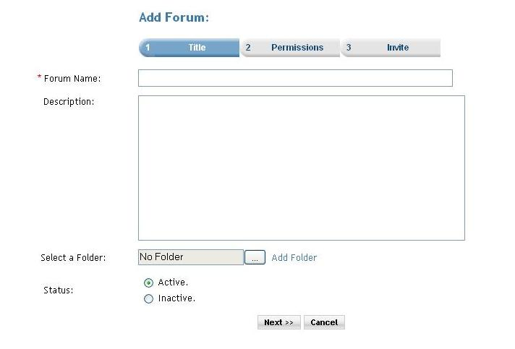

Description: User can add new forum.
- User enters the name of the forum
- User enters description of the forum
- User can select folder by clicking on folder icon for arranging forums in folder structure.
- User can set status of forum active or inactive by selecting desire option (default is active).

Click of the Next button the user is taken to the Step2 screen.

Step 2 Permissions Setting

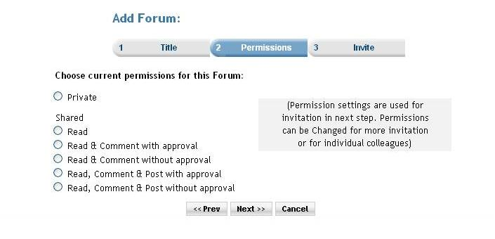

Description: In this step user can set permissions for the forum. Permission settings are used for invitation in next step. Permissions can be changed for more invitation
or for individual colleagues. Premium user can also set the subscription for the service. When the ‘Do you want to charge a fee and/or subscription for access?’ checkbox is selected then the next button click takes the user to the subscription page. And if the checkbox is not checked then the next button click takes the user directly to invitation page.

Step 3 & 4: Subscription page
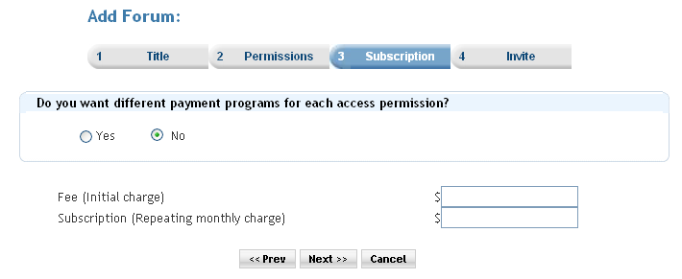
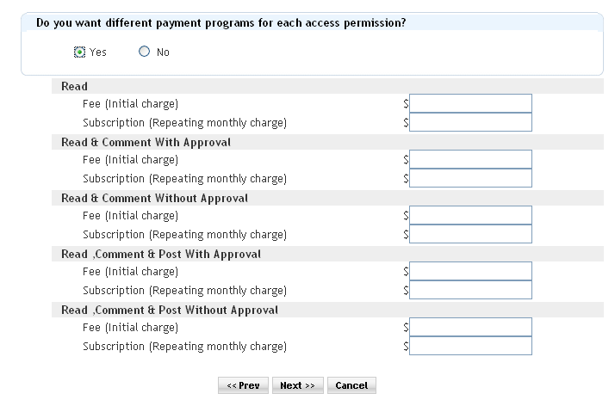

Description: In this step the user sets the subscription. This is the service_prices.php page. After this the user is redirected to the service invitation step.

Step 5(Service invite step) :

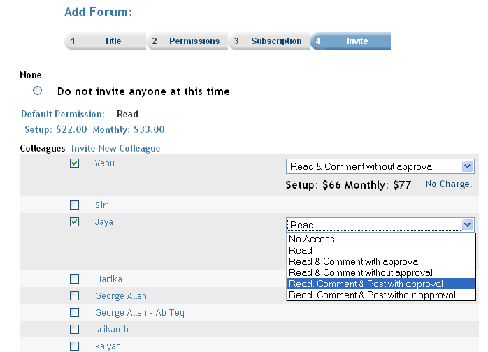

Description : In this step the user invites colleagues with the related permission and subscriptions.

Code object lists

Step 1 and 2
In these steps the all the forum information is taken from the user and using an object of forum class all the detail are stored into the database.
  - Classes : Forums
Created an object of the class forum for storing the information of the forum.
  - Includes : Include files :
forums.inc.php
invitation.inc.php
members.inc.php
  - Functions : createForum($forum) : This is the main function that enters an record to the database in the ‘forums’ table. The function is passed the instance of the class ‘Forums’ as a parameter. This object contains all the information of the forum that is to be created.
updateForum($forum) : This function is used when the user is updating the an existing forum.
  - Graphics : Mainly used the styles_blue.css
  - Flash : No flash.
  - Ajax : No ajax used.
  - Javascript : player.js
  - Pages : forumsetup.php

Step 3, 4 and 5
The subscription step (service_prices.php) and the Invitation step (service_invite.php) These are common steps for all the services.

Database
        - Databases : No change at the database level.
        - Tables : Records were added in the following tables
forums :In the second step(forumsetup.php) here.
subscription_serviceprices : In the service_prices.php the records are added.
memberinvitationmessage : In the service_invite.php the records are added. Common for all the services.
memberinvitations : In the service_invite.php.
common for all the services.
        - Fields : No change.

