UI Flow 2
Step 1 - Detail entry step : 2
Step 2 Permissions Setting 3
Step 3 Subscription Step : 4
Step 4 Invitation step : 5
Code object lists 6
Step 1 and 2 6
Step 3 and 4 6
Database 7

UI Flow
The following steps are the User Interface flow for adding a Forum service :

Step 1 - Detail entry step :

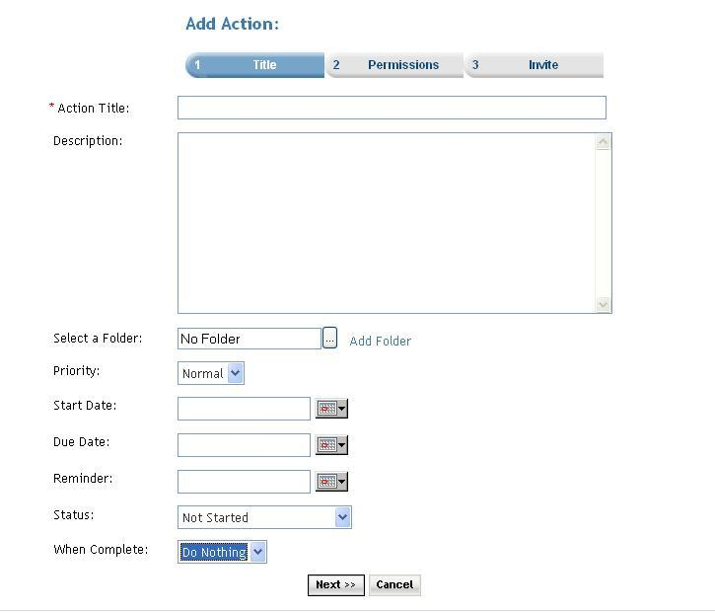

Description: User can add new action.
- User enters the title of the action
- User enters description of the action
- User can select folder by clicking on folder icon for arranging forums in folder structure.
- User can set priority for the action as normal/high or low by selecting proper value from drop down list
- User selects start date from date picker.
- User selects due date from date picker.
- User selects reminder date from date picker.
- User can set status of action by selecting desire option from drop down list.
- User can set action to be taken when action is complete by selecting desire option from drop down list.

Click of the Next button the user is taken to the Step2 screen.

Step 2 Permissions Setting

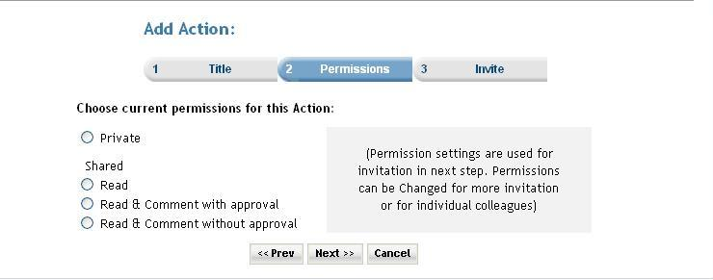

Description: In this step user can set permissions for the action. Permission settings are used for invitation in next step. Permissions can be changed for more invitation
or for individual colleagues. Premium user can also set the subscription for the service. When the ‘Do you want to charge a fee and/or subscription for access?’ checkbox is selected then the next button click takes the user to the subscription page. And if the checkbox is not checked then the next button click takes the user directly to invitation page.

Step 3 Subscription Step :

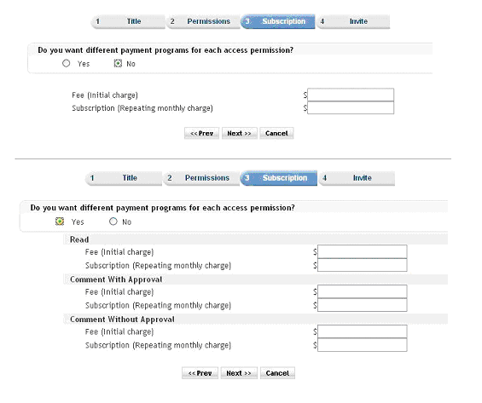

Step 4 Invitation step :

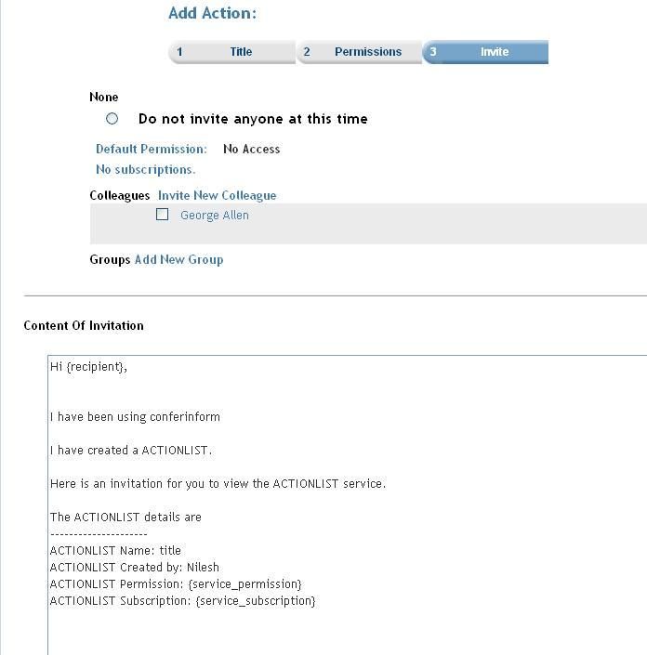

Description: User can invite members by selecting members from the list and click on finish to complete the add action entry. User can go back to previous step by clicking on prev button or can cancel entry by clicking on cancel button.

Code object lists

Step 1 and 2
In these steps the all the action information is taken from the user and using an object of ActionList class all the detail are stored into the database.
  - Classes : ActionList
Created an object of the class ActionList for storing the information of the action.
  - Includes : Include files :
members.inc.php
includes/session.inc.php
invitation.inc.php
Functions addAction($argActionList): This is the main function that enters an record to the database in the ‘ActionList’ table. The function is passed the instance of the class ‘ActionList ‘ as a parameter. This object contains all the information of the Action that is to be created.
updateAction($argActionList): This function is used when the user is updating the an existing Action.
  - Graphics : Mainly used the styles_blue.css
  - Flash : No flash.
  - Ajax : No ajax used.
  - Javascript : player.js
  - Pages : actionlistsetup.php

Step 3 and 4
The subscription step (service_prices.php) and the Invitation step (service_invite.php) These are common steps for all the services.

Database
        - Databases : No change at the database level.
        - Tables : Records were added in the following tables
actionlist :In the second step(actionlistsetup.php) here.
subscription_serviceprices : In the service_prices.php the records are added.
memberinvitationmessage : In the service_invite.php the records are added. Common for all the services.
memberinvitations : In the service_invite.php.
Common for all the services.
        - Fields : No change.

