UI Flow 2
Step 1 2
Step 2 Permissions Setting 3
Step 3 Subscription step : 4
Step 4 Invitation step : 5
Code object lists 6
Step 1 and 2 6
Step 3 and 4 6
Database 7

UI Flow
The following steps are the User Interface flow for adding a document service :

Step 1 - Detail entry step :

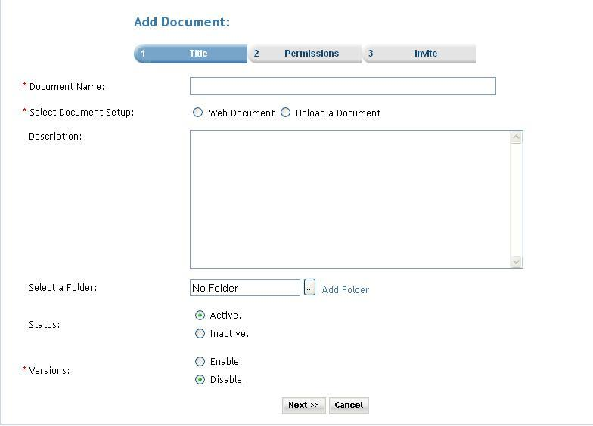

Description: User can add new document.
- User enters the name of the document
- There are two options for document setup
  - Web document: user can create document by using tool for writing document.
  - Upload a document
    - User can upload document by selecting document through browse window.
- User enters document description
- User can select folder by clicking on folder icon for arranging documents in folder structure.
- User can set status of document active or inactive by selecting desire option (default is active).
- User can set status of document enable or disable by selecting desire option (default is disable).

Click on the Next button the user is taken to the Step2 screen.

Step 2 Permissions Setting

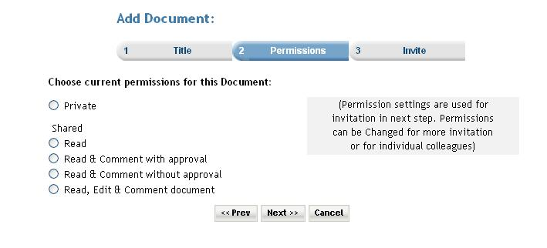
Description: In this step user can set permissions for the document. Permission settings are used for invitation in next step. Permissions can be changed for more invitation
or for individual colleagues. Premium user can also set the subscription for the service. When the ‘Do you want to charge a fee and/or subscription for access?’ checkbox is selected then the next button click takes the user to the subscription page. And if the checkbox is not checked then the next button click takes the user directly to invitation page.

Step 3 Subscription step :

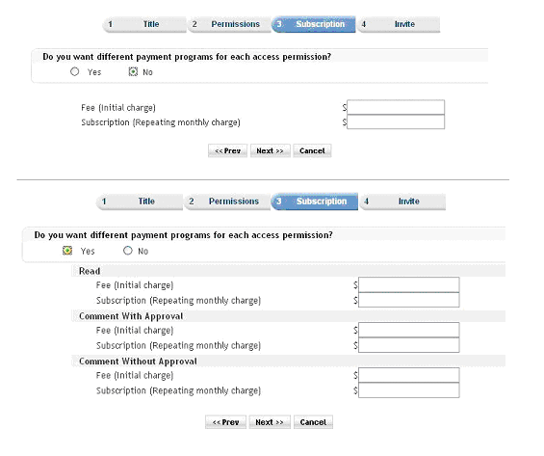

Step 4 Invitation step :

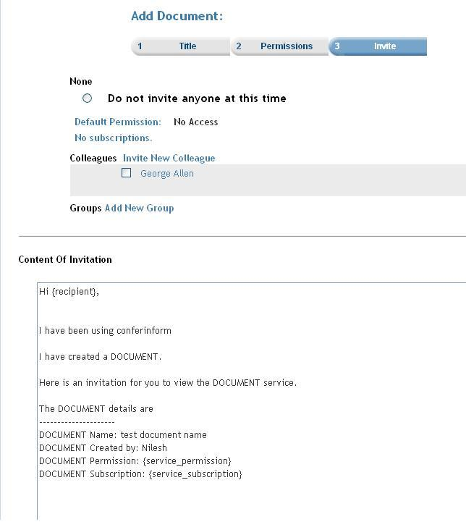

Description: User can invite members by selecting members from the list and click on finish to complete the add document entry. User can go back to previous step by clicking on prev button or can cancel entry by clicking on cancel button.

Code object lists

Step 1 and 2
In these steps the all the document information is taken from the user and using an object of Document class all the detail are stored into the database.
  - Classes : Document
Created an object of the class Document for storing the information of the Document.
  - Includes : Include files :
members.inc.php
includes/session.inc.php
groups.inc.php
documents.inc.php
posters.inc.php
invitation.inc.php
  - Functions createDocument($argDocObj): This is the main function that enters an record to the database in the ‘documentmaster’ table. The function is passed the instance of the class ‘Document‘ as a parameter. This object contains all the information of the Document that is to be created.
updateDocument($argDocObj): This function is used when the user is updating the an existing Document.
  - Graphics : Mainly used the styles_blue.css
  - Flash : No flash.
  - Ajax : No ajax used.
  - Javascript : player.js
  - Pages : documentsetup.php

Step 3 and 4
The subscription step (service_prices.php) and the Invitation step (service_invite.php) These are common steps for all the services.

Database
        - Databases : No change at the database level.
        - Tables : Records were added in the following tables
documentmaster :In the second step(documentsetup.php) here.
subscription_serviceprices : In the service_prices.php the records are added.
memberinvitationmessage : In the service_invite.php the records are added. Common for all the services.
memberinvitations : In the service_invite.php.
Common for all the services.
        - Fields : No change.

