UI Flow 2
Step 1 2
Step 2 Permissions Setting 3
Step3 Template 3
Step 4 Subscription Step 4
Step 5 Invitation step : 5
Code object lists 6
Step 1, 2 and 3 6
Step 4 and 5 6
Database 7

UI Flow
The following steps are the User Interface flow for adding a blog service :

Step 1 - Detail entry step :

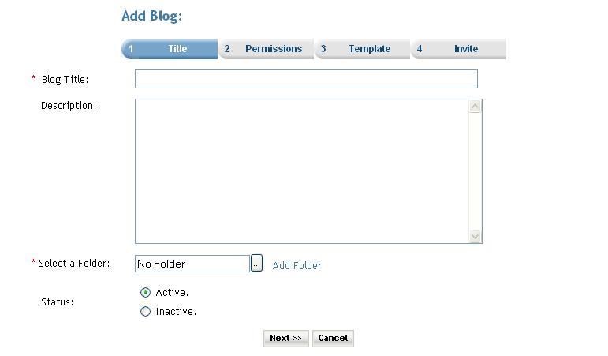

Description: User can add new blog.
- User enters the Title of the blog
- User enters blog description
- User must select folder by clicking on folder icon for arranging blog in folder structure.
- User can set status of blog active or inactive by selecting desire option (default is active).

Click on the Next button the user is taken to the Step2 screen.

Step 2 Permissions Setting

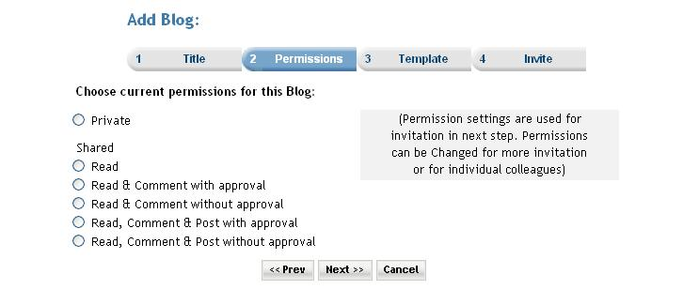
Description: In this step user can set permissions for the blog. Permission settings are used for invitation in next step. Permissions can be changed for more invitation
or for individual colleagues. Premium user can also set the subscription for the service. When the ‘Do you want to charge a fee and/or subscription for access?’ checkbox is selected then the next button click takes the user to the subscription page. And if the checkbox is not checked then the next button click takes the user directly to template page.

Step3 Template

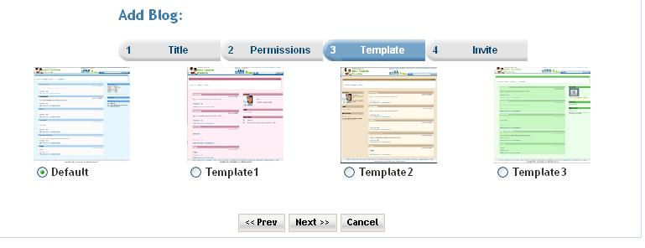

- Description : There are predefined templates present so that the user can select from those templates to create the blog. When this option is selected the user is taken to Step4 screen.
Step 4 Subscription Step

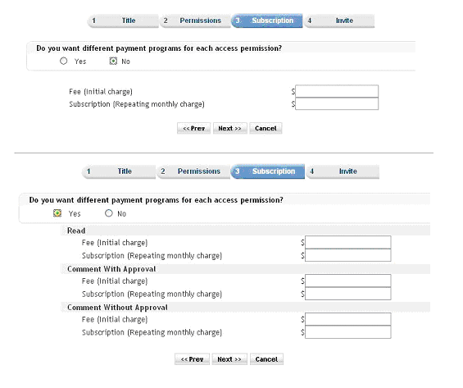

Step 5 Invitation step :

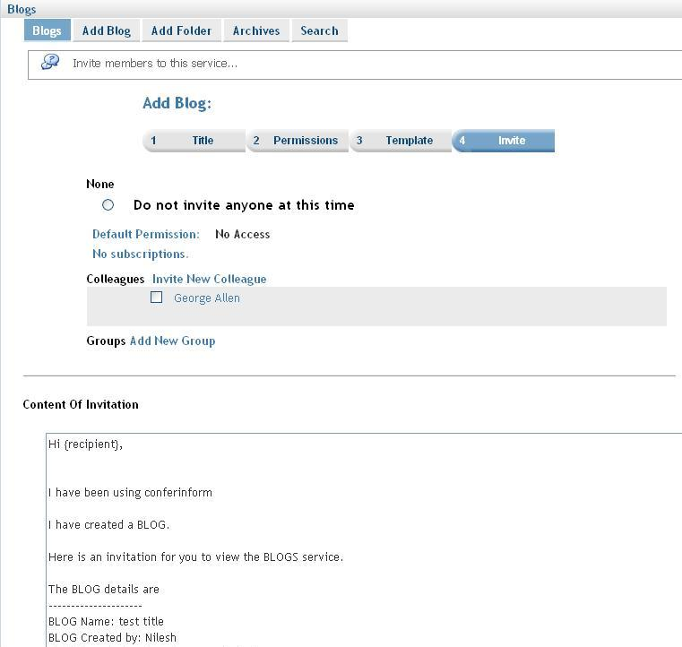

Description: User can invite members by selecting members from the list and click on finish to complete the add blog entry. User can go back to previous step by clicking on prev button or can cancel entry by clicking on cancel button.

Code object lists

Step 1, 2 and 3
In these steps the all the blog information is taken from the user and using an object of Blog class all the detail are stored into the database.
  - Classes : Blog
Created an object of the class Blog for storing the information of the Blog.
  - Includes : Include files :
members.inc.php
groups.inc.php
blogs.inc.php

  - Functions createBlog($argBlog): This is the main function that enters an record to the database in the ‘blogs’ table. The function is passed the instance of the class ‘Blog‘ as a parameter. This object contains all the information of the Blog that is to be created.
updateBlog($argBlog): This function is used when the user is updating the an existing Bolg.
  - Graphics : Mainly used the styles_blue.css
  - Flash : No flash.
  - Ajax : No ajax used.
  - Javascript : blogsetup.js

  - Pages : blogsetup.php

Step 4 and 5
The subscription step (service_prices.php) and the Invitation step (service_invite.php) These are common steps for all the services.

Database
        - Databases : No change at the database level.
        - Tables : Records were added in the following tables
blogs :In the second step(blogsetup.php) here.
subscription_serviceprices : In the service_prices.php the records are added.
memberinvitationmessage : In the service_invite.php the records are added. Common for all the services.
memberinvitations : In the service_invite.php.
Common for all the services.
        - Fields : No change.

