UI Flow 2
Step 1 - Detail entry step 2
Step 2 Permissions Setting 3
Step 3 Subscription step 4
Step 4 Invitation step 5
Code object lists 6
Step 1 and 2 6
Step 3 and 4 6
Database 7

UI Flow
The following steps are the User Interface flow for adding a News service :

Step 1 - Detail entry step

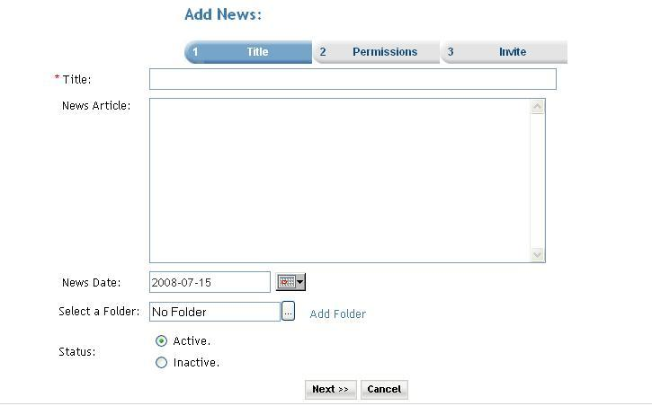

Description: User can add new news item.
- User enters the Title of the News item
- User enters News article
- User selects date created from date picker.
- User can select folder by clicking on folder icon for arranging news in folder structure.
- User can set status of news active or inactive by selecting desire option (default is active).

Click on the Next button the user is taken to the Step2 screen.

Step 2 Permissions Setting

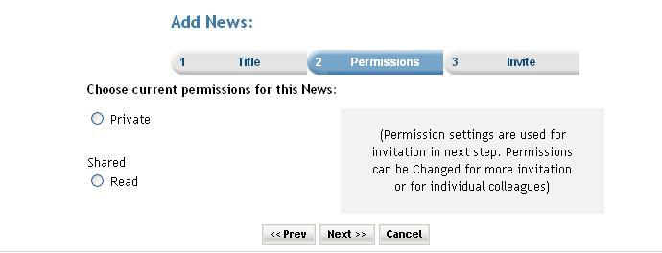

Description: In this step user can set permissions for the news article. Permission settings are used for invitation in next step. Permissions can be changed for more invitation
or for individual colleagues. Premium user can also set the subscription for the service. When the ‘Do you want to charge a fee and/or subscription for access?’ checkbox is selected then the next button click takes the user to the subscription page. And if the checkbox is not checked then the next button click takes the user directly to invitation page.

Step 3 Subscription step

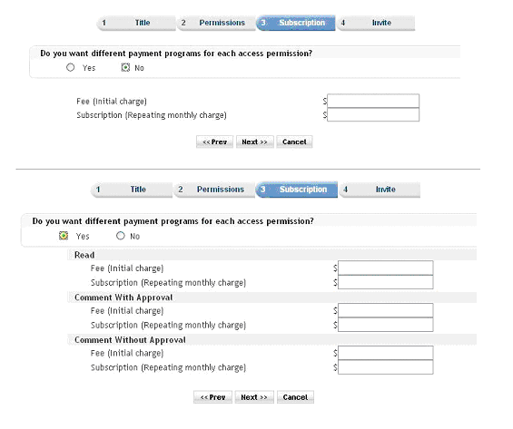

Step 4 Invitation step

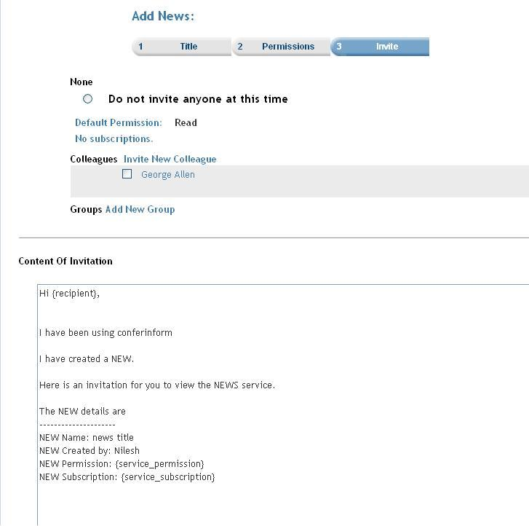

Description: User can invite members by selecting members from the list and click on finish to complete the add news article entry. User can go back to previous step by clicking on prev button or can cancel entry by clicking on cancel button.

Code object lists

Step 1 and 2
In these steps the all the news information is taken from the user and using an object of OrganizationNews class all the detail are stored into the database.
  - Classes : OrganizationNews
Created an object of the class OrganizationNews for storing the information of the news.
  - Includes : Include files :
includes/org_session.inc.php
organizations.inc.php
news.inc.php
  - Functions postNews($argNews): This is the main function that enters an record to the database in the ‘news’ table. The function is passed the instance of the class ‘OrganizationNews ‘ as a parameter. This object contains all the information of the news that is to be created.
updateNews($argNews): This function is used when the user is updating the an existing news.
  - Graphics : Mainly used the styles_blue.css
  - Flash : No flash.
  - Ajax : No ajax used.
  - Javascript : player.js
  - Pages : newssetup.php

Step 3 and 4
The subscription step (service_prices.php) and the Invitation step (service_invite.php) These are common steps for all the services.

Database
        - Databases : No change at the database level.
        - Tables : Records were added in the following tables
news :In the second step(newssetup.php) here.
subscription_serviceprices : In the service_prices.php the records are added.
memberinvitationmessage : In the service_invite.php the records are added. Common for all the services.
memberinvitations : In the service_invite.php.
Common for all the services.
        - Fields : No change.

