UI Flow 2
Step 1 2
Details Entry step: 2
Step 2 3
Step 3A 4
Step 3B 4
Step 4 5
Code object lists 6
Step1 : 6
Step2 : 7
Step3A & 3B: (service_prices.php) 8
Step4 : (project_invite.php) 9
Database 10

UI Flow
The following steps are the User Interface flow for adding a Project service:

Step 1

Details Entry step:

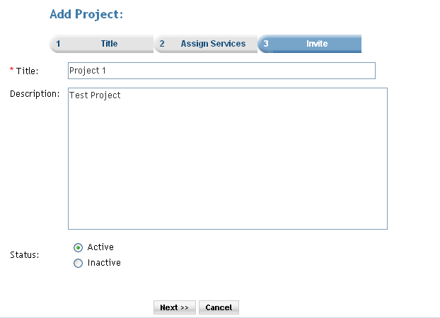

Description: In this step the user can enter the details for the project. The title, some description for the project, and the status of the project can be set here. When the next button is clicked the user is taken to Step 2 the assign services step.

Step 2

Assign Services:

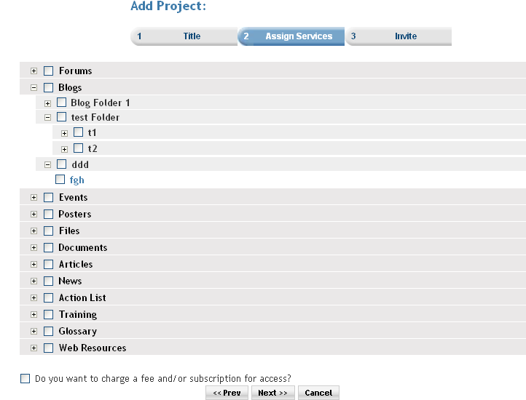

Description: In this step the user assigns services to the project. All the services created by the user are shown to her/him. Then the user can select any number of the services and assign them to the project. These services further can also be accessed by the members of that particular project.

If user select subscription checkbox, and when the next button is clicked the user is taken to Step 3A the subscription step.

Step 3A

Subscriptions charge entry step:

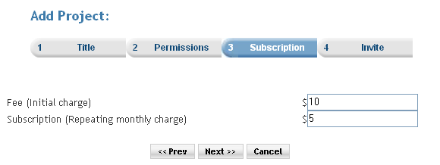

Description: In this step the user can enter the Fee i.e. “Initial charge” & Subscription i.e. “Repeating monthly charge” details for the project. When the next button is clicked the user is taken to Step 3B the subscription verify step.

Step 3B

Subscription verify step:
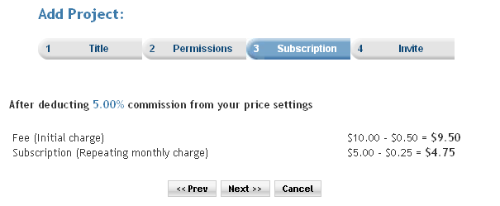

Description: In this step the user can see the Fee i.e. “Initial charge” & Subscription i.e. “Repeating monthly charge” details for the project by deducting 5.00% commission from your price settings. When the next button is clicked the user is taken to Step 4 the invitation step.

Step 4
Invitation step:
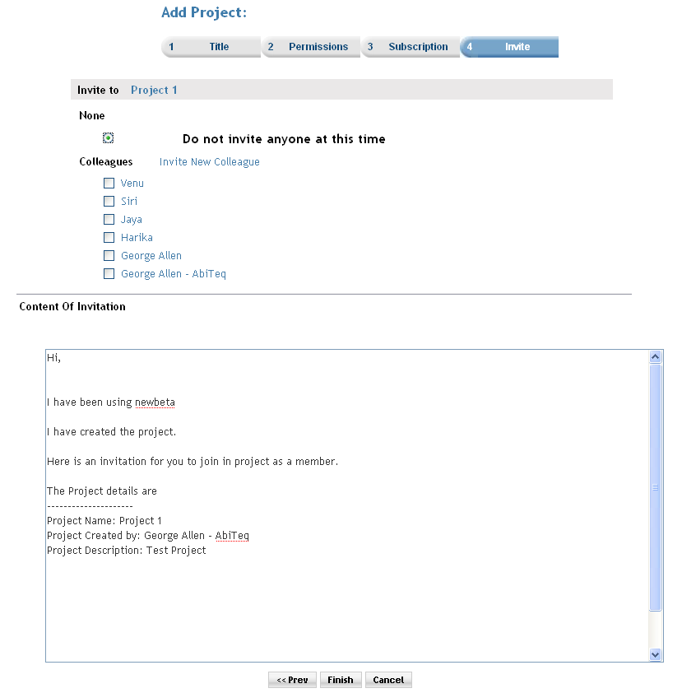

Description: In this step the user have following options to invite 1. None, 2. Colleagues, 3. Groups, 4. Organizations.
- None – this option do not invite anyone at this time.
- Colleagues – already present colleagues or new colleagues can be invited.
- Groups – already present Group or we can add new Group and it can be use to invite.
- Organizations – already present organizations can be invited.

Content of Invitation show format of the invitation that will be sent to the invited colleagues. When the finish button is clicked the user is taken to project home page.

Code object lists

Step1 : (project_setup.php)

In this step the user enters the name of project, description of the project, status of the project.

On this page the user is given to enter only the details of the project and select the project setup type.

On click of the next button the user is redirected to the project_assignservices.php.

  - Classes : “project_setup.php” file uses “Project” class to create object. The created object stores all the project deatails and using getPropsFromPost() function

  - Includes : Mainly includes the following files :
config.php
members.inc.php
session.inc.php
projects.inc.php

  - Functions : Mainly “createProject()” function is used. This function is passed the project class object as a parameter. The object contains all the details of the project. A record is inserted to the “projectmaster” table using the object.
  - Graphics : The css mainly used is style_blue.css
  - Flash : No flash is used.
  - Ajax : No ajax used.
  - Javascript : player.js
  - Pages : project_setup.php

Step2 : (project_assignservices.php)

In this step the user is given options to select, assign services to this Project and create a Project. If the checkbox of subscription is checked then option three will enable. The project_assignservices.php checks for the selected option and shows the appropriate screen on the second step.
a. Classes : No class are used here.
b. Includes : Mainly includes the following files:
The include files related to all the services are been included. Such as:
forums.inc.php
blogs.inc.php
events.inc.php

Functions: Mainly assignSeriviceToProject() is used.
The project ID, selected service ID is mainly used by the function and an entry is made to the “projectservices” table.
The other functions mainly used are addFoldersToProjectByForum(), addFoldersToProjectByBlog(), etc related to each inform service. The function addFoldersToProjectByForum() select the category ID or the service ID of the selected services on the project_assignservices.php page and inserts a record in the “projectservices” table. It inserts the ID’s of the selected category r the service to the table.In this way same kind of function is been used for all the services.

- Graphics : The css mainly used is style_blue.css
- Flash : No flash is used.
- Ajax : No ajax used.
- Javascript : js/ proj_assignper.js
This file contains the javascript functions which are used to handle the events of check box, radio buttons, etc.
- Pages : project_assignservices.php

On click of the next button the user is redirected to the service_prices.php i.e. 3A.

Step3A & 3B: (service_prices.php)

In this step the user enters the Fee (Initial charge), Subscription (Repeating monthly charge).

On click of the next button the user is redirected to the service_prices.php again for verification of subscription. It will show the details of Fee, Subscription by deducting 5.00% commission from price settings.

- Classes : No class are used here.
- Includes : Mainly includes the following files :
invitation.inc.php
services.inc.php
subscriptions.inc.php
payments.inc.php

- Functions : No important functions used.
- Graphics : The css mainly used is style_blue.css
- Flash : No flash is used.
- Ajax : No ajax used.
- Javascript : event.js
- Pages : service_prices.php

Step4 : (project_invite.php)

  - Classes : No class are used here.
  - Includes : Mainly includes the following files :
      - projects.inc.php
      - colleagues.inc.php
      - invitation.inc.php
      - actionlist.inc.php
  - Functions : Following are the functions which are mainly used :
      - getMemberInvitationStatus () : this function is used to get Member Invitation Status.
      - sendInvitation() : This function is used to save a record in the ‘Memberinvitations’ table. And to send message to the invited colleagues.
  - Graphics : The css mainly used is style_blue.css
  - Flash : No flash is used.
  - Ajax : No ajax used.
  - Javascript : invite.js
  - Pages : project_invite.php

Database
        - Databases : No change at the database level.
        - Tables : Records were added in the following tables
projectmaster :In the first step(project_setup.php) here.
projectservices :In the second step(project_assignservices.php)
subscription_serviceprices : In the service_prices.php the records are added.
Memberinvitations : In the final invite step.
        - Fields : No change.

